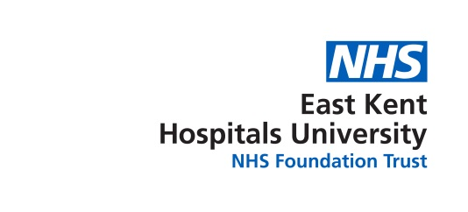

Equality, Diversity & Inclusion Strategy 2023-2025
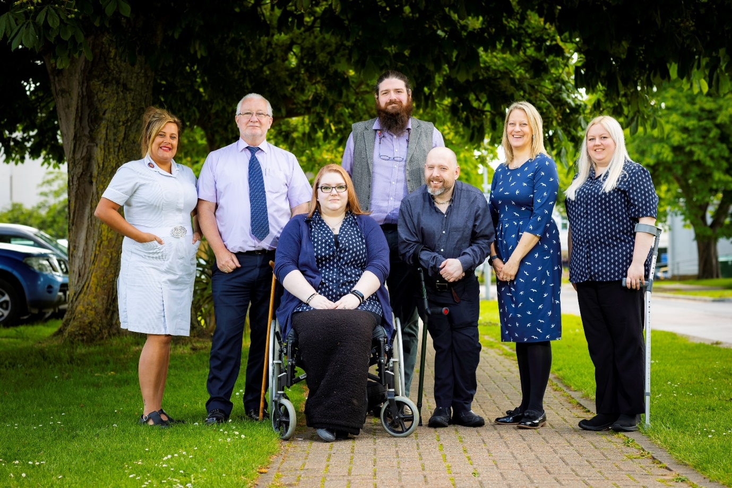

Contents
- Executive summary
- Overview
- The national context
- The People Promise
- EKHUFT improvement journey
- A note on language
- High impact action one
Chief executives, chairs and board members must have specific and measurable EDI objectives to which they will be individually and collectively accountable.
- High impact action two
Embed fair and inclusive recruitment processes and talent management strategies that target under-representation and lack of diversity.
- High impact action three
Develop and implement an improvement plan to eliminate pay gaps.
- High impact action four
Develop and implement an improvement plan to address health inequalities within the workforce.
- High impact action five
Implement a comprehensive induction, onboarding and development programme for internationally-recruited staff.
- High impact action six
Create an environment that eliminates the conditions in which bullying, discrimination, harassment and physical violence at work occur.
- Our approach, next steps
- Conclusion

Executive summary by Andrea Ashman, Chief People Officer
Our aim is to become a truly inclusive organisation that eliminates the conditions where discrimination occurs. To achieve this, we must commit ourselves to better understand and address all forms of discrimination and inequality. We know this will be a challenging task given the current inequalities faced by our workforce. We are motivated to make meaningful, long lasting change. It is clear from national research and benchmarking, the information we collect and the feedback we receive, that there can be a difference in experience and outcomes for certain groups of staff. For example, the response to the COVID-19 pandemic has shone greater light on the impact of health inequalities and sadly we know that staff from ethnic backgrounds don’t experience the same opportunities for career development as their white colleagues.
Therefore, we are committed to taking all the necessary actions to achieve our aim of creating an inclusive organisation. To support this, we have carried out a detailed assessment of our current position including a range of engagement activities to understand the issues and what we can do to improve and move beyond compliance to lead in establishing equitable and inclusive workplace environments.
Our equality, diversity and inclusion (EDI) strategy identifies some key issues of inequality in the Trust and outlines our commitment to improvement. The strategy contains a range of actions we will take to achieve our aim over the next two years. It also links very closely with a range of our strategies and programmes that are designed to deliver our overall people strategy. Indeed, equality, diversity and inclusion forms one of the five main pillars of our people strategy.
This strategy is an evolving document which will develop over time based on the impact of our EDI actions and feedback from our workforce and patients. We will involve our people and stakeholders to ensure that we have the highest possible levels of engagement and corresponding outcomes and experience. We will also share our progress at regular intervals and look forward to celebrating the progress we are making.
On behalf of the Trust Board, we look forward to working with you to deliver this work to achieve, long-lasting, sustainable and meaningful change.

Overview
The NHS must welcome all, with a culture of belonging and trust. ​We must understand, encourage and celebrate ​diversity in all its forms (NHS People Plan 2020).
This strategy aims to improve equality, diversity and inclusion and to enhance the sense of belonging for the East Kent Hospitals University Foundation Trust (EKHUFT) workforce.
- Equality in the workplace means making sure that everyone has access to the same opportunities. This is not to say that you treat everyone in the exact same manner. Some groups or individuals may need support in different ways in which to access opportunities.
- Diversity at work means considering the differences between people and placing value on those differences. When considering diversity, we’re thinking about representation from people of different backgrounds, identities, and abilities. This includes visible and non-visible characteristics.
- Inclusion is defined as an environment where everyone feels a sense of belonging, valued, accepted and respected of who have the ability to contribute. This concept puts emphasis on the way people feel.
In June 2023, NHS England published the EDI improvement plan which sets out six targeted actions to address direct and indirect prejudice and discrimination, that exists through behaviour, policies, practices and cultures against certain groups and individuals across the NHS workforce. This plan aims to improve the outcomes, experience and culture for those with protected characteristics under the Equality Act 2010 (although it is not limited to these groups) and links to the NHS people plan. The EDI improvement plan was developed through engagement with staff networks and senior leaders, including the health and care women leaders’ network, the race and health observatory, NHS employers and NHS confederation, reflecting the intersectional nature of the plan.

This EDI strategy uses the EDI improvement plan as a framework as it is well-researched, collaboratively produced, recognises the complex issue of inequality and how to address this to facilitate meaningful organisational change.

The Case for Change
Where diversity, across the whole workforce, is underpinned by inclusion, staff engagement, retention, innovation and productivity improve. Inclusive environments create psychological safety and release the benefits of diversity, for individuals and teams, and in turn efficient, productive and safe patient care.

Staff survey 2022 and workforce data reflecting the lived experience of EKHUFT staff demonstrates that we have more to do before we can say inclusive workplace environments are the norm across the Trust:

- 22.2% of the workforce are from ethnic backgrounds and face discrimination across many aspects of their working lives include bullying, harassment or abuse from other staff (staff survey data 2022)
- The NHS Staff Survey along with the Workforce Disability Equality Standard (WDES, 2022) shows that staff with disabilities are under-represented when compared to the general population.

- The NHS staff survey data shows staff with disabilities have experienced more bullying from their colleagues, compared to staff who do not have disabilities.
- Similarly, our LGBTQIA+ colleagues face bullying and harassment at work at higher rates compared to staff who identify as heterosexual.
- There is a significant lack of representation of staff from ethnic backgrounds and with disabilities at board, executive and senior level (Workforce Race Equality Standard WRES, 2022; WDES 2022).
- People with disabilities are shortlisted at lower rates than those without disabilities (WDES, 2022)
- People from ethnic backgrounds are shortlisted at lower rates than staff who are not from ethnic backgrounds (WRES, 2022).

Organisational efficiency correlates with staff and patient experience:

- Staff who are bullied are less likely and less willing to raise concerns and admit mistakes.
- Increased leadership diversity correlates with better financial performance.
- In hospital settings, managing staff with respect and compassion correlates with improved patient satisfaction, infection control, Care Quality Commission (CQC) ratings and financial performance.
- High work pressure, staff perceptions of unequal treatment, and discrimination against staff all correlate adversely with patient satisfaction.
- A workforce that is compassionate and inclusive for all has higher levels of engagement, motivation and wellbeing, which results in better care and reduced staff turnover.
- Fair treatment of every individual in the workforce helps reduce movement of substantive staff into bank and agency roles to avoid discrimination at work.
- A diverse workforce that is representative of the communities it serves is critical to addressing the population health inequalities in those communities.
- Organisations with more diverse leadership teams are likely to outperform their less diverse peers.
- Psychologically safe work environments, where people feel they are treated with dignity and respect, achieve more effective, safer patient care.

Simply put, a diverse workforce in an inclusive environment will likely improve staff engagement, lower turnover and enhance innovation.

This strategy is the start of ongoing, continued improvement.

The National Context

The NHS Long Term Plan
The NHS Long Term Plan sets out an ambitious 10-year vision for healthcare in England the Long Term Plan is ambitious but realistic. It will give everyone the best start in life; deliver world-class care for major health problems, such as cancer and heart disease, and help people age well.
The Long Term Plan commits to the following:
- Move to a new service model in which patients get more options, better support, and properly joined-up care at the right time in the optimal care setting.
- More NHS action on prevention and health inequalities
- Further progress on care quality and outcomes
- How workforce pressures will be tackled, and staff supported
Wide ranging funded programme to update technology
Sustainability Transformation Plans and the Integrated Care System are expected to bring together members organisations and wider partners, adopting a common set of principles and leadership behaviours as they develop and deliver plans
The Long Term Plan demonstrates the need to focus on attracting, retaining and developing all people.

The NHS People Plan
The NHS People Plan was published by NHS England in July 2020, and sets out the actions that organisations, employers, staff and systems need to take.
The NHS people plan includes a specific commitment on looking after our people, which clearly outlines the actions we must take to keep NHS staff safe, healthy and well, both physically and psychologically, with quality health and wellbeing support for everyone.
The plan also includes the NHS People Promise, which outlines behaviours and actions that staff can expect from NHS leaders and colleagues, to improve the experience of working in the NHS for everyone.
The Interim People Plan focuses on four pillars:
- looking after our people – with quality health and wellbeing support for everyone
- belonging in the NHS – with a particular focus on tackling the discrimination that some staff face
- new ways of working and delivering care – making effective use of the full range of our people’s skills and experience
- growing for the future – how we recruit and keep our people, and welcome back colleagues who want to return.

People Promise
The NHS People Promise is a promise we must all make to each
other: to work together to improve the experience of working in
the NHS for everyone.
- We are compassionate and inclusive
- We are recognised and rewarded
- We each have a voice that counts
- We are safe and healthy
- We are always learning
- We work flexibly
- We are a team.
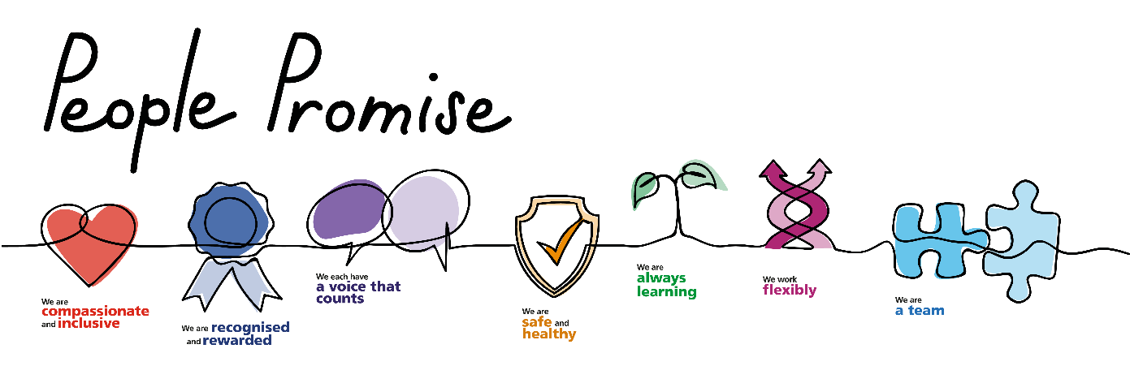

EKHUFT Improvement Journey
We are on a journey of improvement.
In everything we do, we want to make our patients and their families feel cared for, safe, respected and confident we are making a difference, and provide the best possible care and treatment to every one of our patients.
Our mission is Improving health and wellbeing and our vision is to deliver great healthcare from great people.
Our strategic themes, developed with colleagues across the Trust, are Quality and Safety, Patients, People, Partnerships and Sustainability.
Our pillars of change and strategic objectives are driven by our response to Dr Kirkup’s report Reading the Signals, the importance of meeting national standards for planned, cancer and emergency care and the need to be financially sustainable by providing better care and reducing waste.
They are:
- Reducing harm and delivering safe services
- Patients, family and community voices
- Timely access to care
- Care and compassion
- Engagement, listening and leadership
- Organisational development
- Financial sustainability.

Everything we do is underpinned by our values: People feel cared for, safe, respected and confident we are making a difference
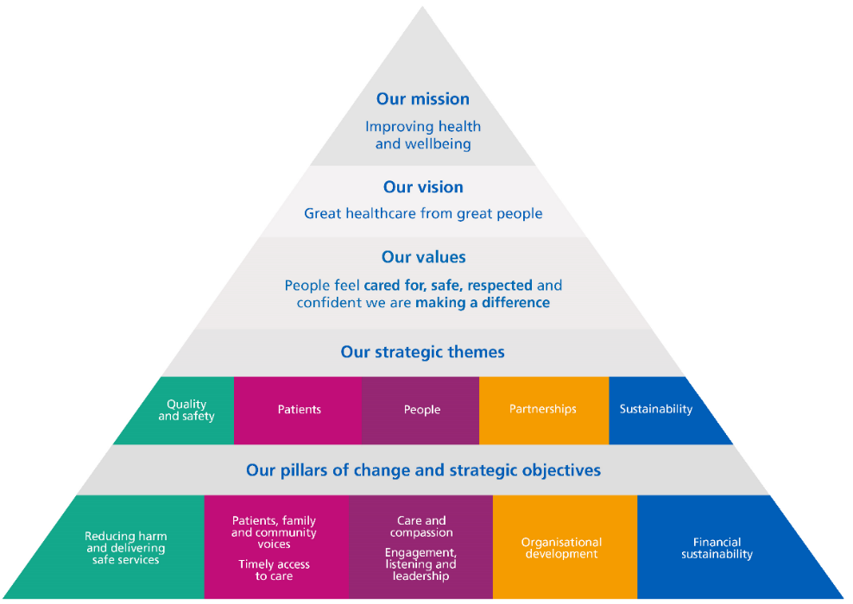

A note on language
In the pursuit of equality, diversity and inclusion, language is powerful and can help to shift attitudes and behaviours. This strategy acknowledges that some definitions and terminology in legislation do not always reflect the identities or lived experience of individuals. This includes, but is not limited to, those with protected characteristics under the Equality Act 2010.

Therefore, while this strategy refers to the protected characteristics as defined in the Equality Act 2010: age; disability; gender reassignment; marriage and civil partnership; pregnancy and maternity; race; religion or belief; sex; sexual orientation, this strategy is intended to positively impact groups and individuals beyond these terms and definitions.

- The term ‘disability’ is used in the strategy as it is defined in the Equality Act 2010, recognising that the Act’s intention is both positive and protective for people with disabilities. The law says someone is disabled if both of these apply: they have a 'physical or mental impairment' and the impairment 'has a substantial and long-term adverse effect on their ability to carry out normal day-to-day activities'. To promote the use of inclusive language and based on feedback from staff networks, the term ‘disabled staff’ is not used and instead the terms ‘staff with disabilities’ or ‘people/individuals with disabilities’ are used. However, we recognise that ‘disability’ is a dynamic term. Under the Equality Act 2010 disability includes neurodiversity. Neurodiversity is a term used to describe a range of neurological differences including, but not exclusive, of dyslexia, dyspraxia, dyscalculia, attention deficit hyperactivity disorder (ADHD), autism.

- The acronym LGBTQIA+ is used in this strategy to refer to individuals who identify as lesbian, gay, bi, trans, queer, intersex, asexual, where the ‘plus’ includes all those identities and sexual orientations not specifically referenced.

- This strategy does not use the term ‘minority’ to describe people from ethnic backgrounds, as they are actually the global majority. This strategy does not use the terms BAME (black, Asian and minority ethnic) and BME (black and minority ethnic) because they emphasise certain ethnic minority groups (Asian and black) and exclude others (mixed, other and white ethnic minority groups). We refer to ethnicity and not race. This is because ethnicity is broader than race and is usually used to refer to long shared cultural experiences, religious practices, traditions, ancestry, language, dialect or national origins. We use ‘staff from ethnic backgrounds’ to refer to all ethnic groups.

We recognise that individuals, communities and groups will identify themselves differently. How people prefer to identify will shift and change over time.

It's important to understand the meaning behind the terms we use to address people and to keep updated and willing to refresh our language so we use appropriate and respectful terms. It’s also imperative to remember that individuals will have their own particular preferences as to how they would describe themselves, and how they would wish to be described.

Identity is extremely personal. You should listen, educate yourself, learn, and politely ask about preferences.

High impact action one
Chief executives, chairs and board members must have specific and measurable EDI objectives to which they will be individually and collectively accountable.

As highlighted in the messenger review, principles of EDI should be embedded as the personal responsibility of every leader and every member of staff. It is in this context that all chief executives, chairs and board members should have distinct objectives on improving inclusion in their organisation and have a personal commitment to mainstream EDI as the responsibility of all, such that the provision of an inclusive and fair culture should become a key metric by which leadership at all levels is judged.

What does this look like in 2025?
- Leaders setting the tone and culture of the organisation.
- Leaders demonstrating compassion and inclusion, and focusing on improvements, as this is key to creating cultures that value and sustain a diverse workforce.
- Staff will in turn feel more empowered to deliver great care and patient experience.

Key measures
- Every board and executive team member to have EDI objectives that are specific, measurable, achievable, relevant, and timebound (SMART) and be assessed against these as part of their annual appraisal process (by March 2024).
- Board members should demonstrate how organisational data and lived experience have been used to improve culture (by March 2025).
- The board to review relevant data to establish EDI areas of concern and prioritise actions. Progress will be tracked and monitored via the Board Assurance Framework (by March 2024).

How will we know we have achieved our targets?
Success metric for high impact action one:
Target | Where we’ll gather the data
Annual chair and chief executive appraisals on EDI objectives. | Board Assurance Framework

High impact action two
Embed fair and inclusive recruitment processes and talent management strategies that target under-representation and lack of diversity.

Evidence shows that diverse boards make better collective decisions for the communities they serve. Talent management strategies must recognise the importance of equitable recruitment and career progression for all staff. If they do not, the Trust risks losing talent because everyone does not see themselves as having the same opportunity, leading to a direct impact on patient care.

What does this look like in 2025?
- Creation and implementation of a talent management plan to improve the diversity of executive and senior leadership teams (by June 2024) and evidence progress of implementation (by June 2025)
- A plan implemented to widen recruitment opportunities within local communities, aligned to the NHS long term workforce plan. To include the creation of career pathways into the NHS such as apprenticeship programmes and graduate management training schemes (by October 2024). Impact should be measured in terms of social mobility across the integrated care system (ICS) footprint.

Key Measures
- Year-on-year improvement in representation of senior leadership (Band 8C and above).
- HEE National Education and Training Survey (NETS) improvement score metric on quality of training
- Increase in diversity in shortlisted candidates
Success metrics for high impact action two:
Target | Where we’ll gather the data
Increase in relative likelihood of staff being appointed from shortlisting across all posts | WRES and WDES
Improved access to career progression, training and development opportunities | NHS Staff Survey
Year-on-year improvement in race and disability representation leading to parity | WRES and WDES

High impact action three
Develop and implement an improvement plan to eliminate pay gaps.

The Trust should take steps to address gender, ethnicity and disability pay gaps in order to become a more inclusive employer.

What does this look like in 2025?
- Implementation of the mend the gap review recommendations for medical staff and development of a plan to apply those recommendations to senior non-medical workforce (by March 2024).
- Analysing of data to understand pay gaps by protected characteristic and put in place an improvement plan. To be tracked and monitored by the board. Reflecting the maturity of current data sets, plans should be in place for sex and race by 2024, disability by 2025 and other protected characteristics by 2026.
- Implementation of an effective flexible working policy including advertising flexible working options on recruitment campaigns (by March 2024)

How will we know we have achieved our targets?
Success metric for high impact action three:
Target | Where we’ll gather the data
Year-on-year reductions in the gender, race and disability pay gaps | Pay gap reporting

High impact action four
Develop and implement an improvement plan to address health inequalities within the workforce.
We aim to do this by, reducing bullying, increasing civility, and having a robust approach to all abuse and harassment. This will address some common causes of ill health, absenteeism and turnover within the workforce which disproportionately impact on those with some protected characteristics, and will improve inclusive team working, staff health and wellbeing.

What does this look like in 2025?
- Line managers and supervisors having regular, effective wellbeing conversations with their teams (by October 2023).
- EKHUFT working in partnership with community organisations such as the NHS Race and Health Observatory, local educational and voluntary sector partners to support social mobility and improve employment opportunities (by April 2025).
- Policy and guidance in place for reasonable adjustments. Reasonable Adjustments are defined as changes an employer makes to remove or reduce a disadvantage related to someone's disability or health condition. This could include physical adaptations or equipment, changes to ways of working and/ or support.

How will we know we have achieved our targets?
Target | Where we’ll gather the data
Improvement in staff health and wellbeing | NHS Staff Survey
Reduction in staff experiencing bullying, abuse, harassment | NHS Staff Survey
Improvement in experiences of staff with disabilities and health conditions | NHS Staff Survey
Reduction in absenteeism and staff turnover | Sickness and turnover reporting

High impact action five
Implement a comprehensive induction, onboarding and development programme for internationally-recruited staff.

What does this look like in 2025?
- Prior to joining the Trust, international recruits receive clear communication, guidance and support around their conditions of employment; including clear guidance on latest Home Office immigration policy, conditions for accompanying family members, financial commitment and future career options (by March 2024).
- Comprehensive onboarding programmes in place for international recruits, drawing on best practice. The effectiveness of the welcome, pastoral support and induction to be measured by turnover, staff survey results and cohort feedback (by March 2024).
- Line managers and teams who welcome international recruits must maintain their own cultural awareness to create inclusive team cultures that embed psychological safety (by March 2024).
- International recruits given access to the same development opportunities as the wider workforce. Line managers proactively supporting their teams to access training and development opportunities and ensure that personal development plans focus on fulfilling potential and opportunities for career progression (by March 2024).

How will we know we have achieved our targets?
Target | Where we’ll gather the data
Sense of belonging for internationally recruited staff | NHS Staff Survey
Reduction in instances of bullying and harassment from team/line manager experienced by (internationally recruited staff) | NHS Staff Survey

High impact action six
Create an environment that eliminates the conditions in which bullying, discrimination, harassment and physical violence at work occur.

What does this look like in 2025?
- Review data by protected characteristic on bullying, harassment, discrimination and violence. Reduction targets to be set (by March 2024) and plans implemented to improve staff experience year-on-year.
- There should be assurances that all staff who enter into formal processes are treated with compassion, equity and fairness, irrespective of any protected characteristics. Where the data shows inconsistency in approach, immediate steps must be taken to improve this (by March 2024).
- Ensure safe and effective policies and processes are in place to support staff affected by domestic abuse and sexual violence (DASV).
- Create an environment where staff feel able to speak up and raise concerns, with steady year-on-year improvements.
- Provide comprehensive psychological support for all individuals who report that they have been a victim of bullying, harassment, discrimination or violence (by March 2024).
- Have mechanisms to ensure staff who raise concerns are protected by the organisation.

How will we know we have achieved our targets?
Year-on-year reduction in discrimination, incidents of bullying and harassment.
Successful launch of EDI related campaigns and initiatives, including but not limited to; anti-racism campaign see me first, rainbow pledge, hidden disability sunflower scheme.
Growth and development of staff networks.
Recognition and celebration of diversity events, including but not limited to; black history month, pride, disability history month, international women’s day.
Robust equality impact assessments completed for polices, service changes.
EDI training and learning opportunities for staff in place.

Our approach
EKHUFT have invested in a small, dedicated EDI Team to drive this work. The team’s mission statement is; working collaboratively with our valuable staff to action meaningful change.

Seeing issues of inequality in isolation means failing to see the whole complex picture of how inequality becomes compounded by many aspects in organisations. Therefore, the EDI team are employing an evidence-based, multi-dimensional approach using Thompson’s PCS Model.

Thompson’s PCS Model provides a multifaceted approach to understanding inequality and addressing it on three interlinked organisational layers; personal (individual behaviours and thoughts), cultural (shared norms and values e.g. in teams, services), structural (policies, processes e.g. recruitment, investigations).

The rationale is that using this systems approach promotes understanding of issues of inequality on each level and also promotes actions being completed to address each level. The EDI team are working with this approach as it has an evidence base for achieving meaningful and long-lasting organisational change.

The power of staff networks
The EDI Team support and work closely with EKHUFT’s five staff networks who are an integral part of the EDI strategy delivery; LGBTQIA+ network; staff disability network; women’s network, neurodiversity network and the ethnic diversity engagement network (EDEN).

Staff networks are a key mechanism for driving meaningful change and making a difference, as well as empowering people with the opportunity to grow personally and professionally. They provide a critical forum for individuals to come together, share ideas, raise awareness of challenges and provide support. Staff networks welcome all staff (and allies) as members. Please see staff zone for more details on staff networks and how to become a member.

Next Steps
Successful application of the strategy requires collaborative working, which will be led by the EDI team working closely with stakeholders, colleagues and teams including staff networks, executive team and board, recruitment, well-being, medical workforce, staff experience, freedom to speak up, business partners, patient voice and involvement team, learning and development and employee relations. The EDI team will consult with each team or stakeholder to create detailed implementation plans for each of the six high impact actions. This will encourage shared responsibility and promote the principle that EDI is everyone’s responsibility.

Progress will be monitored in a number of ways:
- At bi-monthly EDI Steering Group meetings
- As part of the Care Group monthly performance reviews
- At bi-monthly Strategic Workforce Committees
- Regularly at Board meetings
The EDI strategy will be reviewed, updated and approved annually.

You are important. We need your involvement
This is a pivotal moment to seize and lead a whole systems approach to articulate and live up to shared values and act to make a change where everyone has a role to play in the Trust’s organisation’s equality and inclusion effort, through leadership, participation or ally-ship.

The EDI Team are passionate about achieving change and want
to work collaboratively with our valued staff. We welcome staff to share any ideas, whether these be big or small, so we can learn from you;

- Are there any projects or work going on in your team/ service that links to this strategy?
- Do you have any examples of good EDI practice you would like to share?
- Would you like to be actively involved in this work?

All ideas and contributions are welcome, please contact the EDI Team by emailing: ekhuft.edi@nhs.net

Conclusion
EKHUFT must be more inclusive and our leadership more diverse. We have an obligation to improve the experience of staff so that they feel like they belong. This strategy articulates meaningful action to transform the lived experience of our staff and realise the benefits that we know come from greater equality, diversity and inclusion.

There is a wealth of evidence that shows having a diverse workforce and making sure everyone feels part of a team delivers the best care for patients.

It is the job of Trust leaders to take an active role in ending all forms of discrimination, role-model inclusive behaviours and create an environment in which our workforce feel safe and empowered. Everybody has a role to play in supporting, encouraging and promoting equality, diversity and inclusion.

