East Kent Hospitals University

NHS Foundation Trust

**POLICY DOCUMENT**

Learning from Deaths

|  |  |
| --- | --- |
| **Version:** | 3.0 |
| **Author/s:** | Learning from Deaths Facilitator |
| **Approving committee:** | Patient Safety Committee (Chair’s action) |
| **Date approved:** | 11 January 2022 |
| **Date ratified by Policy Authorisation Group:** | 09 February 2022 |
| **Director responsible for implementation:** | Chief Medical Officer |
| **Date issued:** | 22 February 2022 |
| **Next review date:** | January 2025 |
| **Applies to (include subsidiary companies):** | EKHUFT staff |

This policy is available in other formats, for example, in large print, Audio and Easy Read on request. Please contact [ekhuft.edi@nhs.net](mailto:ekhuft.edi@nhs.net)

Version Control Schedule

|  |  |  |  |  |
| --- | --- | --- | --- | --- |
| **Version** | **Date** | **Author** | **Status** | **Comment** |
| 1.0 | Sept-17 | Medical Director 2013-2022 | Final | (Not issued) |
| 2.0 | Feb-19 | LFD Facilitator | Superseded | Reformatting of whole document and addition of points |
| 3 | Jan-22 | Head of Patient Safety and Learning from Deaths Facilitator | Final | Scheduled review |

Policy Reviewers

|  |  |
| --- | --- |
| **Name and Title of Individual** | **Date Consulted** |
| Medical Director: Mortality Clinical Lead | June 2021 |
| Lead Medical Examiner | June 2021 |
| Learning from Deaths Facilitator | June 2021 |
| Learning from Deaths Facilitator | July 2021 |

|  |  |
| --- | --- |
| **Name of Committee** | **Date Reviewed** |
| Mortality Surveillance and Steering Group | 27th October 21 |
| Patient Safety Committee | 11/1/22 |

Summary of Key Changes from Last Approved Version

The key changes from version 2 (February 2019) include:

* Updates to align with the current Serious Incident process
* Inclusion of the Medical Examiner (ME) involvement in the Learning from Deaths process
* Update to the random sample selection criteria
* The role of the Learning from Death (LFD) leads and the LFD panel
* Update to the current Structured Judgement Review (SJR) screening process
* The role of Mortality and Morbidity meetings interfacing with the LFD process
* Process for inclusion of any Hospital at Home related mortality cases
* Process for inclusion of any community mortality cases that raise in-hospital concerns
* Update to how SJR aligns with the complaints and duty of candour process
* The appendices have been replaced to reflect the current Learning from Deaths process

Associated Documentation

Incident Management Policy

Medical Examiner Service Policy

Child Death Review Process Guideline

Complaints Management Policy

Contents

1. Policy Description 5

2. Introduction 5

3. Definitions 6

4. Purpose and Scope 8

5. Duties 9

6. Learning from Deaths Process 10

7. Interactions with Bereaved Families and Carers 12

8. Reporting and governance arrangements 13

9. Policy Development, Approval and Authorisation 13

10. Review and Revision Arrangements 13

11. Policy Implementation 14

12. Document Control including Archiving Arrangements 14

13. Monitoring Compliance 14

14. References 14

15. Appendices 15

Appendix 1 – Summary of Adult Structured Judgement Review process for staff 16

Appendix 2 – Learning from deaths process 18

Appendix 3 – EKHUFT Structured Case Note Review Screening Tool taken from the ME1b form 19

Appendix 4 – EKHUFT Structured Case Note Review Form 20

Appendix 6 – Equality Analysis (EA) 24

Appendix 7 – Policy Implementation Plan 26

1. Policy Description
   1. This policy describes the East Kent Hospital University Foundation Trust (EKHUFT or the ‘Trust’) approach to learning from the death of people who either die while in our care or whose subsequent death may be attributed to our care.
   2. It should be followed in conjunction with the Incident Management Policy (including Duty of Candour) and any subsequent Duty of Candour Policy.
2. Introduction
   1. EKHUFT is required to demonstrate how it responds to, and learns from, deaths of people who either die while in our care or whose subsequent death may be attributable to our care. Our aim is to support our staff to review and learn from deaths and then take effective action to embed improvements.
   2. Learning from deaths of people under our care can help us improve the quality of the care we provide to patients and their families, and identify where we could do more.
   3. The review of mortality cases is undertaken using the Royal College of Physicians Structured Judgement Review (SJR) process to provide a holistic review of the care, identify problems that potentially or did cause harm and decide on the avoidability of death rating.
   4. The introduction of the Medical Examiner Service ensures each patient death is reviewed and discussed with families and carers. Our aim is to enable families and carers to raise and have answered any questions or concerns about the care of patients who have died.
   5. A Care Quality Commission (CQC) review in December 2016, 'Learning, candour and accountability: A review of the way NHS trusts review and investigate the deaths of patients in England' found that some providers were not giving learning from deaths sufficient priority and so were missing valuable opportunities to identify and make improvements in quality of care. Following on from this in March 2017, the National Quality Board (NQB) introduced new guidance for NHS providers on how they should learn from the deaths of people in their care. That report required NHS trusts to undertake a number of actions to ensure a systematic approach to identifying those deaths requiring review and a systematic, standardised approach to the performance, reporting and learning from those reviews, working with commissioners to review and improve local approaches following the death of people receiving care.
   6. The NHS Patient Safety Strategy (2019) outlines the requirement to publish data annually within trust quality accounts and the independent scrutiny of deaths by the medical examiner system.
   7. The research suggests that preventable deaths due to problems in care make up around 5% of deaths and that the variation seen in the ‘Summary Hospital-Level Mortality Indicator’ (SHMI) and other indicators is likely to be due to other factors. However, the burden of preventable deaths nationally is still substantial and further analysis locally is required to attempt to identify those areas where there may be systematic and correctible shortcomings in care that contribute to preventable deaths. Findings from the Francis report 2013 show that ‘higher than expected’ mortality rates were at worse ignored or manipulated and at best the subject of poorly functioning non-systematic mortality review meetings in which failings in the quality of care were not confronted or corrected. Essentially, there are four levels of scrutiny that a provider can apply to the care provided to someone who dies; medical examiner review, death certification, case record review and investigation. They do not need to be initiated sequentially and an investigation may be initiated at any point, this already happens within the Trust through the incident reporting system (Datix) and identification of serious incidents involving mortality.
3. Definitions
5. 1. **Case record review**: A structured desktop review of a case record/note, carried out by clinicians, to determine whether there were any problems in the care provided to a patient. Case record review is undertaken routinely to learn and improve in the absence of any particular concerns about care. This is because it can help find problems where there is no initial suggestion anything has gone wrong. It can also be done where concerns exist, such as when bereaved families or staff raise concerns about care.
   2. **Death certification**: The process of certifying, recording and registering death, the causes of death and any concerns about the care provided. This process includes identifying deaths for referral to the coroner.
   3. **Investigation**: The act or process of investigating; a systematic analysis of what happened, how it happened and why. This draws on evidence, including physical evidence, witness accounts, policies, procedures, guidance, good practice and observation - in order to identify the problems in care or service delivery that preceded an incident to understand how and why it occurred (see Incident Management Policy 2021).
   4. **Learning**: The process of identifying what goes well in order to improve, or what may need to change in order to reduce the risk, in service provision or of future occurrence of similar events. Learning also ensures that any identified information derived from these processes is shared through robust governance processes, and acted upon.
   5. **Mortality review:** A systematic exercise to review a series of individual case records using a structured or semi-structured methodology to identify any problems in care and to draw learning or conclusions to inform any further action that is needed to improve care within a setting or for a particular group of patients.
   6. **Preventable death**: A death due to a problem in care is a death that has been clinically assessed using a recognised methodology of case record/note review and determined more likely than not to have resulted from problems in healthcare and therefore to have been potentially avoidable.
   7. **Serious Incident**: Serious Incidents in healthcare are adverse events, where the consequences to patients, families and carers, staff or organisations are so significant, or the potential for learning is so great, that a heightened level of response is justified. Serious Incidents include acts or omissions in care that result in unexpected or avoidable death, unexpected or avoidable injury resulting in serious harm – including those where the injury required treatment to prevent death or serious harm – abuse, Never Events, incidents that prevent (or threaten to prevent) an organisation’s ability to continue to deliver an acceptable quality of healthcare services, and incidents that cause widespread public concern resulting in a loss of confidence in healthcare services.
   8. **Service review**: consists of a Structured Judgement Review of 30–40 cases (or the maximum number available at the time of review if less than 30 cases) to enable the production of breadth and depth of information regarding a service, area of care or management of a medical condition. After an initial review it will be decided by the clinician leading the review if a repeat review is required the following year other than high risk groups which will be reviewed yearly.
   9. **Structured Judgement Review (SJR):** The SJR is a tool used by trained reviewers to review the patient record in a critical manner commenting on specific phases of clinical care. The process provides end data on both quantitative and qualitative information on care that goes well, or not so well and examines both interventions and holistic care – which means that the whole record is reviewed, including nursing notes. The reviewer will also consider the avoidability of death. SJR is usually based on one reviewer’s judgement, with a second-stage review where there is cause for concern at first review.
   10. **Timely**: Cases reviewed as close to death as possible, in view of potential duty of candour needs. Ideally, within six weeks of death or in cases selected as a result of cluster or service review selection within six weeks of selection.
6. Purpose and Scope
   1. The Trust is required to demonstrate how it responds to, and learns from, deaths of people who either die while in our care or whose subsequent death may be attributable to our care. This policy outlines the minimum number and the categories of deaths that should be reviewed:
      1. All deaths where bereaved families and carers, or staff, have raised a significant concern about the quality of care provision;
      2. All deaths of those with learning disabilities and with severe mental illness;
      3. All deaths which are subject to a Her Majesty’s Coroner’s review;
      4. All deaths in areas where people are not expected to die, for example in relevant elective procedures;
      5. All cardiac arrests more than 24hrs after admission to hospital (Emergency Department cardiac arrests will be included);
      6. Through the Mortality Surveillance and Steering Group (MSSG), all deaths where the senior coders have concerns during their process of coding the cause of death;
      7. A service or cluster review of deaths in a service specialty, particular diagnosis or treatment group where an ‘alert’ has been raised through whatever means (for example via a Summary Hospital-level Mortality Indicator or other elevated mortality alert, concerns raised by audit work, concerns raised by the CQC or another regulator, or where death has occurred linked to a Regulation 28 from the coroner (Report to Prevent Future Deaths);
      8. A service review of deaths classified as High-Risk Groups (HRGs), for example stroke, acute kidney injury, pneumonia, COPD, MI, fractured neck of femur, emergency laparotomy pathway;
      9. A service review of deaths, where learning will inform our existing or planned improvement work, for example improving sepsis care. In order to maximise learning, such deaths will be reviewed thematically;
      10. A further random sample of other deaths that do not fit the identified categories so that the Trust can take an overview of where learning and improvement is needed most. The aim is that this will be every 1 in 15 eligible deaths per speciality. The random sample size maybe adjusted and this would be approved by the MSSG.
   2. Following the introduction of the Medical Examiner role, all deaths are scrutinised by an independent Medical Examiner following discussions with the clinical teams and families. Refer to the Medical Examiners Policy for further detail.
   3. This policy will ensure that:
      1. There will be consistency in the quality of patient mortality reviews within the Trust;
      2. The outcome of such reviews will be clearly documented and archived;
      3. Clear reporting mechanisms will be in place, to escalate any areas of concern identified by mortality reviews, so that the organisation is aware and can ensure appropriate action is taken;
      4. Mortality monitoring data is analysed and acted upon as appropriate;
      5. Learning is shared through the Trust and any other relevant route or external Health Care provisions.
   4. The policy applies to all staff whether they are employed by the Trust permanently, temporarily, through an agency or bank arrangement, are students on placement, are party to joint working arrangements or are contractors delivering services on the Trust’s behalf.
7. Duties
   1. **The Trust Board of Directors** has overall responsibility for monitoring and learning from deaths across the Trust.
   2. **A non-executive director** will be responsible for the oversight of the programme and to ensure that progress is made against the national recommendations.
   3. **The Chief Medical Officer** is responsible for ensuring the Trust complies fully with all national requirements for the programme.
   4. **The Mortality Surveillance and Steering Group**, under the chairmanship of the Chief Medical Officer representative, will be responsible for the review and monitoring of Trust learning from avoidable deaths. This group has the required multi-disciplinary and multi-professional membership and will continue to meet monthly to oversee the process.
   5. **Consultants appointed to the Learning from Deaths Panel** are responsible for the completion of a second multidisciplinary review of patient deaths considered, on first review, to have poor or very poor overall care or be potentially avoidable. The Learning from Deaths Panel will consider whether the patient death meets the criteria for reporting as a Serious Incident and escalate to the Serious Incident Panel; or whether learning should be taken forward via the speciality Mortality and Morbidity (M&M) meeting or any other relevant forum.
   6. **Consultants and clinicians nominated as SJR leads** for the learning from deaths programme are responsible for co-ordinating the training of their colleagues in the process and ensuring the programme is delivered and functioning in line with national recommendations.
   7. **Senior medical staff (ST4 and above) and senior members of other professional groups**, including band 7 and above nurses will be trained by either the tier 1 SJR trainers or the LFD Facilitators and participate in the process of undertaking SJR’s to support a thorough and holistic review process.
   8. **The role of Medical Examiners** provides further clarity about which deaths should be reviewed by actively identifying and allocating appropriate cases through the completion of the ME1B form on the EKHUFT Patient Tracking List (PTL) (see screening criteria – Appendix 3).
   9. **Learning from Death (LFD) Facilitators**: Staff employed by the trust to work in close collaboration with the clinical staff within each speciality team to develop a systematic and collaborative review of mortality and morbidity cases using the nationally recognised Structured Judgement review methodology and to ensure that a learning platform is created for these cases through the Mortality and Morbidity meetings.
8. Learning from Deaths Process
   1. An initial screening is completed by the Medical Examiner team via an electronic form on the PTL to assess whether there is an indication that further review of the patient’s death may identify learning. The criteria align to the national recommendations (see Appendix 3). Subsequent cases can be screened by the Learning from Death Facilitators should a cause for concern arise or the case forms part of a cluster review.
   2. The Trust has adopted a modified version of the SJR tool. The SJR tool is completed via an electronic form online accessible from the Mortality PTL (SJR Live tab). The SJR tool prompts the reviewer to consider various elements of care, identify any problems of care, and provide an overall avoidability of death judgement score (see Appendix 4).
   3. This SJR methodology is robust and evidence-based by the Royal College of Physicians in 2016 as a nationally recognised tool for both mortality and morbidity case reviews. The reviews will generate the information the Trust is required to publish. The annual Quality Account includes the number of deaths, reviews and deaths considered avoidable. This report also includes the learning from the deaths considered to be avoidable.
   4. Senior Trust health professional staff will be trained to undertake case record reviews and act on what they learn by interfacing their reviews with the Mortality and Morbidity (M&M) meetings to identify the learning and ensure any changes in practice are embedded.
   5. To ensure objectivity case record reviews will be conducted by clinicians other than those directly involved in the care of the deceased.
   6. The judgement of whether a problem may have contributed to a death requires careful review of the care that was provided against the care that would have been expected at the time of death. Research has shown that when case record review identifies a death that may have been caused by problems in care, that death tends to be due to a series of problems none of which would be likely to have caused the death in isolation but which in combination can contribute to the death of a patient.
   7. When a problem in care potentially contributing to the patient’s death is identified, a second review will be triggered and the case reviewed at the multidisciplinary Learning from Deaths panel. This review may lead to a serious incident investigation or a relevant M&M discussion. If a first review case identifies more than 50:50 avoidability the case will immediately be escalated as a possible SI (see 5.5).
   8. All deaths of patients with learning disabilities (LD) will be reviewed by the LD lead for the Trust using the SJR process and learning will be fed back into the relevant M&M meetings as well as reported to the national Learning Disability and Autistic People NHS programme (LeDeR). LeDeR process see the flowchart (appendix 5).
   9. All maternity and child deaths will be reviewed using the Trust Death Review Process in those individual specialities areas.
   10. Any Mortality cases under the Hospital at Home (H@H) team at the time of death or within one month of discharge from the H@H team will be referred to the Learning from Death Facilitators for consideration for SJR. If SJR is required the case will be presented at a relevant M&M meeting with one of the H@H team present to identify any learning.
   11. Specialities that have on average one eligible death, or less, a month will have all their cases screened for an SJR.
   12. Any deaths out of hospital e.g. in the community or hospice, where there is a concern raised around a recent in-hospital episode of care will be screened by the LFD facilitators for an SJR to be undertaken by the most relevant in-hospital clinician. The outcome of this review will be fed back by the LFD Facilitators to the external member of staff or team raising the concern and the case discussed at the most relevant internal M&M meeting.
9. Interactions with Bereaved Families and Carers
   1. The Trust will engage meaningfully and compassionately with bereaved families and carers in relation to all stages of responding to a death.
   2. Bereaved families and carers will:
      1. Be treated as equal partners following bereavement;
      2. Receive a clear, honest, compassionate and sensitive response in a sympathetic environment;
      3. Receive a high standard of bereavement care which respects confidentiality, values, culture and beliefs, including being offered appropriate support. This includes providing, offering or directing people to specialist suicide bereavement support;
      4. Be informed of their right to raise concerns about the quality of care provided;
      5. Receive timely, responsive contact and support in all aspects of an investigation process, with a single point of contact and liaison.
   3. Bereaved families’ and carers’ views should help to inform decisions about whether a review or investigation is needed through discussions with the Medical Examiner team.
   4. Bereaved families and carers should be partners in an investigation to the extent, and at whichever stages, that they wish to be involved, as they offer a unique and equally valid source of information and evidence that can better inform investigations.
   5. Bereaved families and carers who have experienced the investigation process will be supported to work in partnership with the Trust in delivering training for staff in supporting family and carer involvement where they want to.
   6. The SJR information can be considered as part of the investigation of an incident or formal complaint. The SJR can be translated in the context of other information within the complaint response by the Patient Advice and Liaison Service Team. Refer to the Complaints Management Policy for more detail of the complaints procedure.
   7. Any bereaved family concerns that have not been signposted to the Complaints Management team should be handled by the Care Group Governance teams and if SJR has been undertaken this can be translated in the context of other information to form part of the complaint response.
10. Reporting and Governance Arrangements
    1. The Mortality Surveillance and Steering Group (MSSG) monitors the compliance with completion of SJRs and learning from SJRs by receiving a monthly report from the LFD Facilitators. The standards being monitored include rates of Trust SJR completion rates, individual speciality SJR completion rates, progress on cases requiring a second review, speciality compliance with M&M meetings, identified problems in care that have caused harm.
    2. The Quality and Safety Committee and Trust Board of Directors receive a quarterly report from the Mortality Surveillance and Steering Group detailing the mortality data measured using the Hospital Standardised Mortality Ratio (HMSR) via the Integrated Performance Report.
    3. The Board of Directors receives assurance regarding learning from deaths as part of the annual Quality Account review.
    4. The Patient Safety Committee will receive six-monthly reports from the MSSG on Learning from Deaths.
    5. The Chief Executive Management Group will receive a verbal update on Learning from Deaths and M&M progress at each meeting.
11. Policy Development, Approval and Authorisation
    1. This policy will be approved by the Patient Safety Committee after appropriate consultation with the Mortality Surveillance and Steering Group.
    2. This policy will be ratified by the Policy Authorisation Group.
12. Review and Revision Arrangements
    1. This policy will be reviewed after a three year period, or earlier where necessary due to changes in national guidance or organisational updates.
    2. It will be ratified by the Policy Authorisation Group every three years, or when there are significant changes and/or changes to underpinning legislation in accordance with the policy for the Development and Management of Trust Policies (and other Procedural Documents).
13. Policy Implementation
    1. Refer to Appendix 6
14. Document Control including Archiving Arrangements
    1. This policy conforms to the policy for the Development and Management of Procedural Documents.
    2. Archiving of this policy will conform to the EKHUFT Information Lifecycle policy, which sets out EKHUFT’s policy on the management of its information.
    3. The policy, in its previous form and future version formats, will be maintained in Trust’s policy management system.
    4. This policy will be uploaded to the Trust’s policy management system.
15. Monitoring Compliance
    1. 30% of EKUFT adult deaths (excluding maternity and child deaths) will be reviewed using the SJR process, monitored by the Mortality Surveillance and Steering Group as part of the monthly SJR report.
    2. 100% of SJR’s to be undertaken within six weeks of death, monitored through the SJR patient tracking list dashboard.
    3. All speciality teams are compliant with the M&M Terms of Reference, monitored by the Mortality Surveillance and Steering Group as part of the monthly SJR report.
16. References

Care Quality Commission (2016) Learning, candour and accountability: A review of the way NHS trusts review and investigate the deaths of patients in England.

Available at: <https://www.cqc.org.uk/sites/default/files/20161213-learning-candour-accountability-full-report.pdf>

Healthcare Commission (2009) Investigation Into Mid Staffordshire NHS Foundation Trust. Available at: <https://cdn.ps.emap.com/wp-content/uploads/sites/3/2009/06/Investigation_into_Mid_Staffordshire_NHS_Foundation_Trust.pdf>

Hogan H, Healey F, Neale G, Thomson R, Vincent C, Black N. (2012) Preventable deaths due to problems in care in English acute hospitals: a retrospective case record review study. British Medical Journal Quality and Safety. Sep;21(9):737-45. doi: 10.1136/bmjqs-2011-001159. Available at: <https://pubmed.ncbi.nlm.nih.gov/22927487/>

Hogan H, Zipfel R, Neuburger J, Hutchings A, Darzi A, Black N et al. (2015) Avoidability of hospital deaths and association with hospital-wide mortality ratios: a retrospective case record review and regression analysis. British Medical Journal, Jul 14;351:h3239. doi: 10.1136/bmj.h3239. Available at: <https://www.bmj.com/content/351/bmj.h3239/>

National Quality Board (2017) National Guidance on Learning from Deaths: A Framework for NHS Trusts and NHS Foundation Trusts on Identifying, Reporting, Investigating and Learning from Deaths in Care. Available at: <https://www.england.nhs.uk/wp-content/uploads/2017/03/nqb-national-guidance-learning-from-deaths.pdf>

NHS England and NHS Improvement (2019) The NHS Patient Safety Strategy: Safer culture, safer systems, safer patients. Available at: [https://www.england.nhs.uk/wp-content/uploads/2020/08/190708_Patient_Safety_Strategy_for_website_v4.pdf](https://www.england.nhs.uk/wp-content/uploads/2020/08/190708_Patient_Safety_Strategy_for_website_v4.pdf%20)

1. Appendices

Appendix 1 – Summary of Adult Structured Judgement Review process for staff

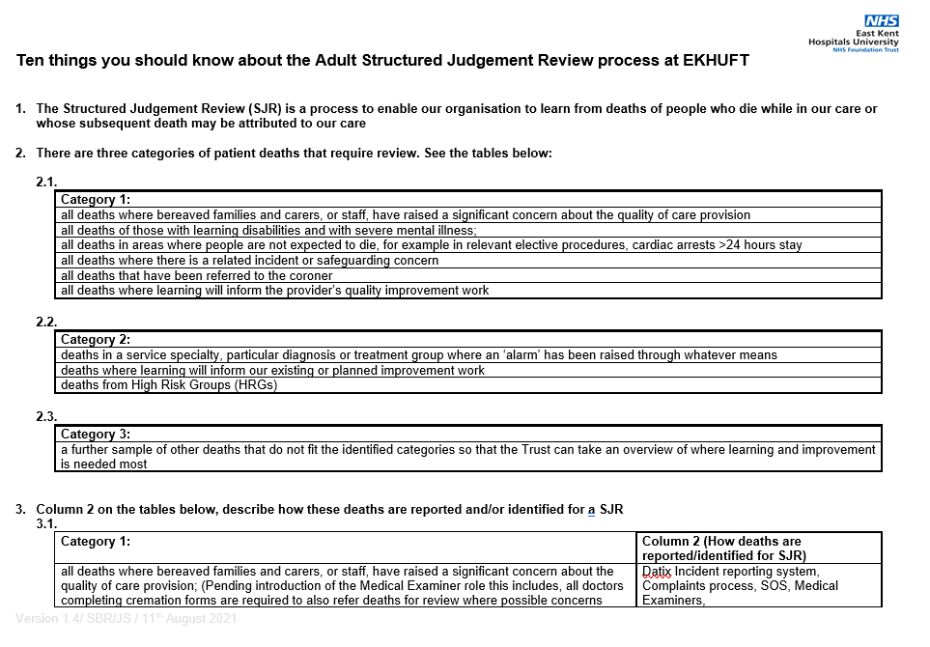

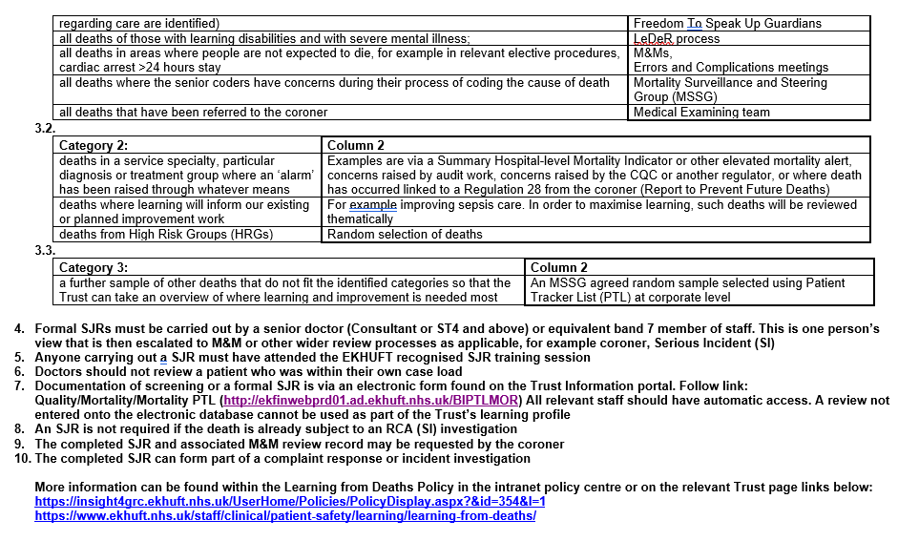

Appendix 2 – Learning from deaths process

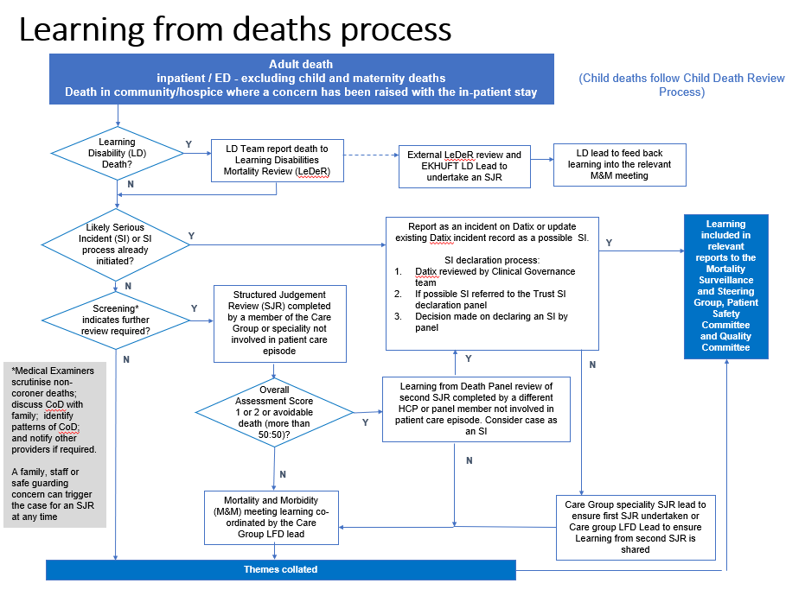

Appendix 3 – EKHUFT Structured Case Note Review Screening Tool taken from the ME1b form

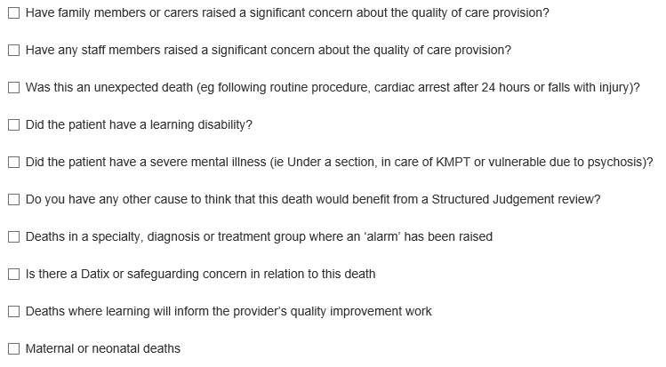

Appendix 4 – EKHUFT Structured Case Note Review Form

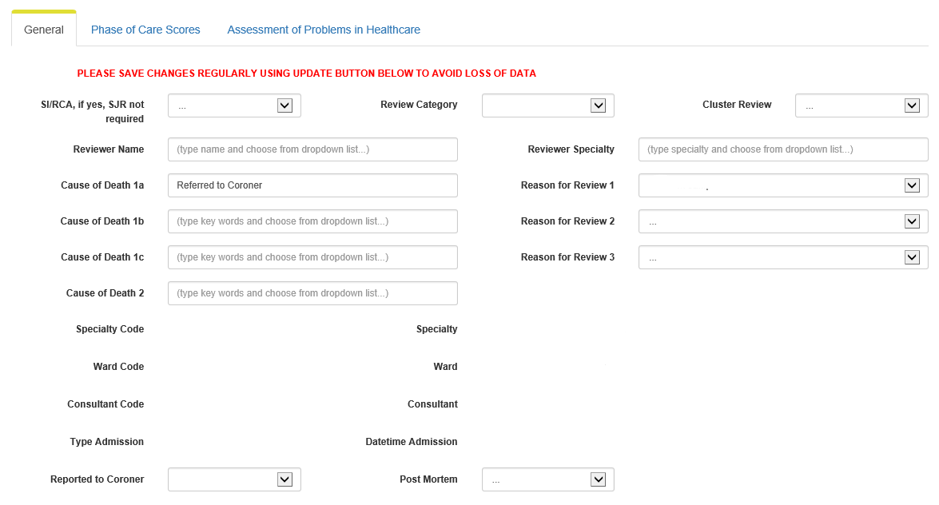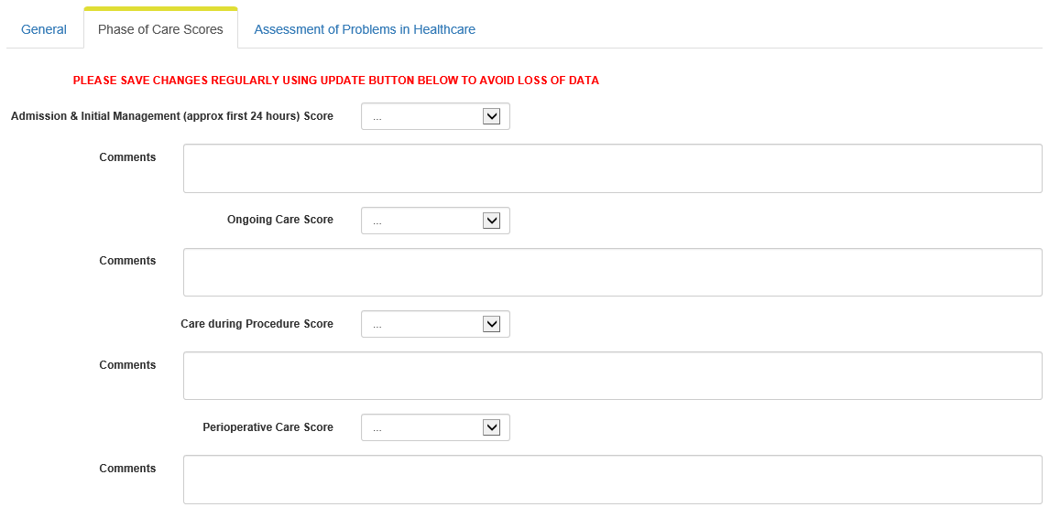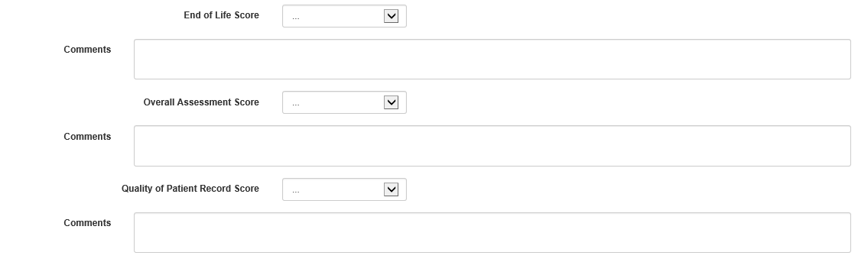

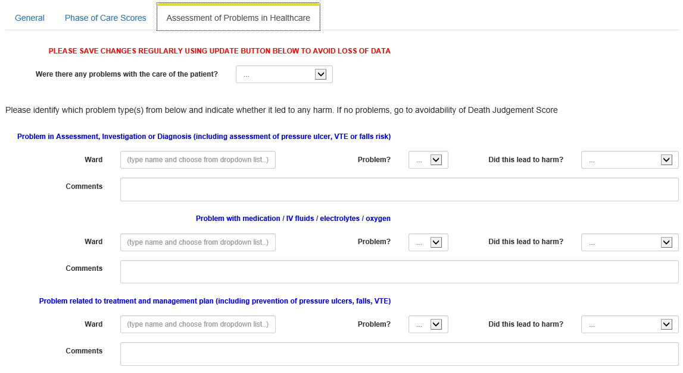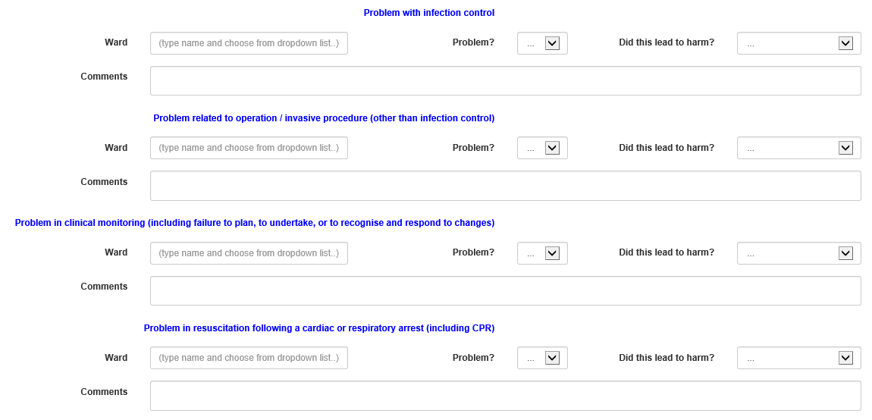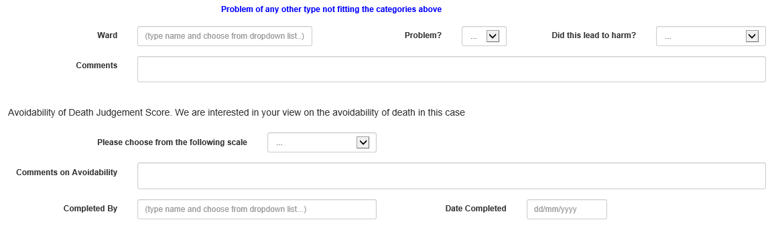

Appendix 5 – LeDeR Process Flow Chart

NB. The LeDeR process is an external organisation to EKHUFT

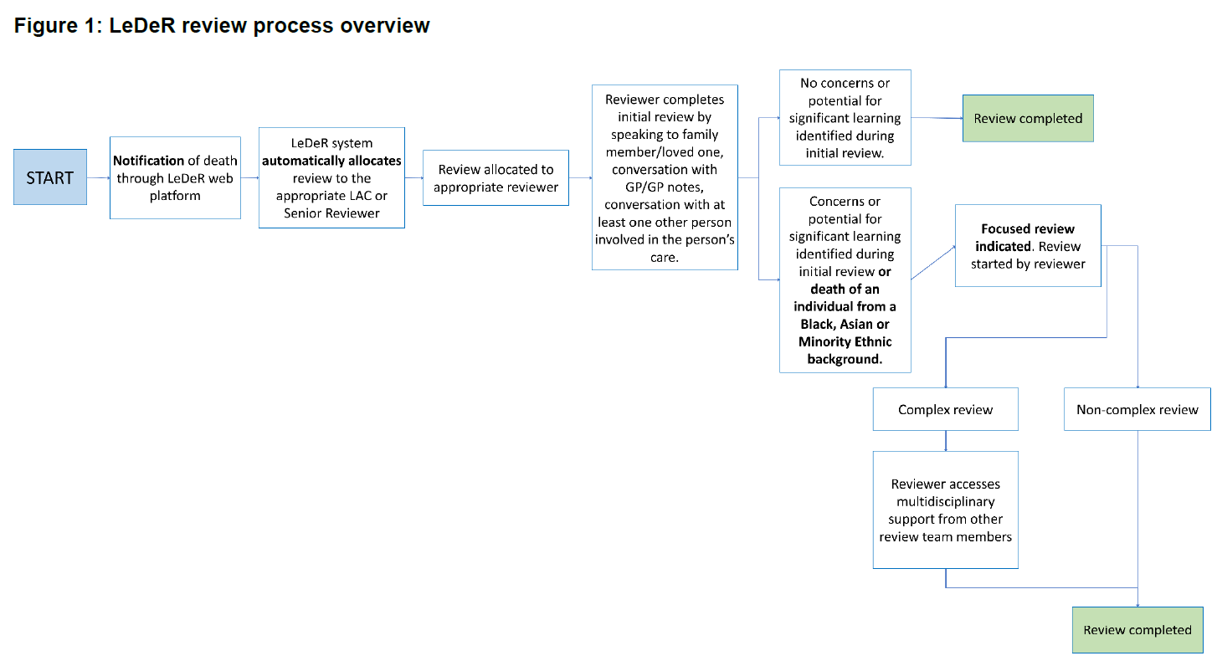

Appendix 6 – Equality Analysis (EA)

An Equality Analysis not just about addressing discrimination or adverse impact; the policy should also positively promote equal opportunities, improved access, participation in public life and good relations.

**Person completing the analysis**

|  |  |
| --- | --- |
| Name | **Jackie Shaba** |
| Job title | Learning from Deaths Facilitator |
| Care Group / Department | Corporate Care Group |
| Date completed | 5/8/21 |
| Who will be impacted by this policy? | Staff (EKHUFT)  Staff (Other)  Service Users  Carers  Patients  Relatives |

**Assess the impact of the policy on people with different protected characteristics.**

When assessing impact, make it clear who will be impacted within the protected characteristic category. For example, it may have a positive impact on women but a neutral impact on men.

|  |  |  |
| --- | --- | --- |
| **Protected characteristic** | **Characteristic Group** | **Impact of decision**  Positive/Neutral/Negative |
| Age | **Yes adults (children not included in the policy)** | **positive** |
| Disability (please see additional information below) | **yes** | **positive** |
| Gender reassignment | **yes** | **positive** |
| Marriage and civil partnership | **yes** | **positive** |
| Pregnancy and maternity | **no (not included in this policy)** |  |
| Race | **yes** | **positive** |
| Religion or belief | **yes** | **positive** |
| Sex | **yes** | **positive** |
| Sexual orientation | **yes** | **positive** |

If there is insufficient evidence to make a decision about the impact of the policy it may be necessary to consult with members of protected characteristic groups to establish how best to meet their needs or to overcome barriers.

|  |  |
| --- | --- |
| Has there been specific consultation on this policy? | No |
| Did the consultation analysis reveal any difference in views across the protected characteristics? | n/a |

**Disability Protected Characteristic**

We need to ensure that we meet the Accessible Information Standard (AIS) which aims to support people with a disability, sensory loss or impairment to receive information they can understand and any communication support they need.

For more information, go to:

[Accessible information standard (AIS) for East Kent Hospitals staff](https://staff.ekhuft.nhs.uk/Interact/Pages/Content/Document.aspx?id=2205)

[Understanding accessible information - NHS England](https://www.england.nhs.uk/ourwork/patients/accessibleinfo/)

|  |  |
| --- | --- |
| **Mitigating negative impact:**  Where any negative impact has been identified, outline the measures taken to mitigate against it. | n/a |

|  |  |
| --- | --- |
| **Conclusion:**  Advise on the overall equality implications that should be taken into account by the policy approving committee. | There are no envisaged equality implications from the introduction of this policy. The Learning from Deaths Policy is a positive opportunity for learning from all cases that include any of the protected characteristics. |

Appendix 7 – Policy Implementation Plan

To be completed for each version of policy submitted for approval.

|  |  |
| --- | --- |
| **Policy Title:** | Learning from Deaths Policy |
| **Version Number:** | 3 |
| **Director Responsible for Implementation:** | Chief Medical Officer |
| **Implementation Lead:** | Mortality Lead |

|  |  |
| --- | --- |
| **Staff Groups affected by policy:** | All clinical staff groups |
| **Subsidiary Companies affected by policy:** | n/a |
| **Detail changes to current processes or practice:** | The key changes from the original version of February 2019 include updates of the current Learning from Death process and how this interface with the Mortality and Morbidity meetings. The requirements of the Patient Safety Strategy and the role of the new Learning from Deaths leads and panel, in particular with relation to the second review process.  A further update has been made to the ME involvement now in the SJR screening process and a standard written for how the Hospital and Home team will capture any cases relevant to their team. The Interaction with Bereaved Families and Carers has been updated to clarify how the SJR’s are communicated as part of the Duty of Candour process. |
| **Specify any training requirements:** | Ongoing SJR training with the Speciality teams |
| **How will policy changes be communicated to staff groups/ subsidiary companies?** | Changes to the policy will be communicated through each M&M speciality meeting and to the SJR leads through the LFD lead consultants |