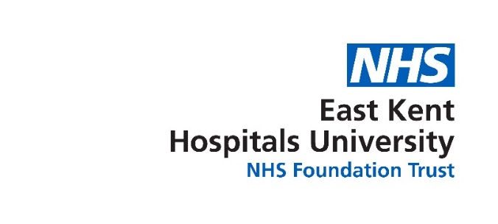

East Kent Hospitals University

NHS Foundation Trust

**TRUST POLICY**

PATIENT SAFETY INCIDENT RESPONSE POLICY

|  |  |
| --- | --- |
| **Document properties:** | **Detail:** |
| **Version** | 1.0 |
| **Author** | Deputy Director of Quality Governance |
| **Policy Owner** | Head of Patient Safety and Improvement |
| **Executive Director Responsible for Policy** | Chief Nursing and Midwifery Officer |
| **Approving committee** | Quality and Safety Committee |
| **Date approved** | 04/04/2024 |
| **Date ratified by Policy Authorisation Group** | 27/08/2024 |
| **Date issued** | 03 October 2024 |
| **Next scheduled review date** | May 2025 |

|  |  |
| --- | --- |
| **Applies to:** | **Yes/No** |
| **Trust staff (specify groups e.g. clinical/non-clinical)** | All EKHUFT Staff with regard to patient safety |
| **Subsidiaries** | Spencer Private Hospitals |
| **2gether Support Solutions Ltd. as a service provider (hard and soft facilities services)** | No |

**This policy is available in other formats, for example, in large print, Audio and Easy Read on request. Please contact** [**ekhuft.psirf@nhs.net**](mailto:ekhuft.psirf@nhs.net)

Version Control Schedule

|  |  |  |  |  |
| --- | --- | --- | --- | --- |
| Version | Date | Author | Status | Comment |
| 1.0 | June 2024 | Head of Patient Safety and Improvement | Final | New Policy |
|  |  |  |  |  |

Policy Reviewers

If policy references children/young people or includes references to medicines policy must be reviewed by the relevant group.

|  |  |
| --- | --- |
| Title and Care Group of Individual | Date Consulted |
| Head of Patient Safety and Improvement, Quality Governance Directorate | 24/03/2024 |
| Director of Quality Governance, Quality Governance Directorate | 29/03/2024 |
| Patient Safety Leads | 22/02/2024 |
| Deputy Director of Quality and Governance | 24/03/2024 |
| Associate Director of Safeguarding | 24/06/2024 |

|  |  |
| --- | --- |
| Name of Committee | Date Reviewed |
| Quality & Safety Committee | 02/04/2024 |
| Policy Authorisation Group | 27/08/2024 |

Summary of Key Changes from Last Approved Version

Not applicable - New policy

Associated Documentation

Incident Management Policy

Complaints Management Policy

Patient Safety Incident Response Plan

Contents

1. Policy Description 4

2. Introduction 4

3. Definitions 4

4. Purpose and Scope 5

5. Duties 5

6. Patient Safety Culture 7

7. Patient Safety Partners 8

8. Addressing Health Inequalities 9

9. Engaging and Involving Patients, Families and Staff Following a Patient Safety Incident 10

10. Patient Safety Incident Response Planning 11

11. Responding to Patient Safety Incidents 15

12. Quality Review 21

13. Complaints and Appeals 21

14. Policy Development, Approval and Authorisation 21

15. Review and Revision Arrangements 22

16. Policy Implementation 22

17. Document Control including Archiving Arrangements 22

18. Monitoring and Assurance 22

19. References 23

Appendix 1: Safety Action Development Process 24

Appendix 2: Incident Response Decision Making Flowchart 25

Appendix 3: Quality Governance Structure Chart 26

Appendix 4: Equality Analysis 27

Appendix 5: Policy Implementation Plan 30

1. Policy Description
   1. The aim of this policy is to support the requirements of the Patient Safety Incident Response Framework (PSIRF).
   2. This document sets out East Kent Hospitals University NHS Foundation Trust’s approach to developing and maintaining effective systems and processes for responding to patient safety incidents. The purpose of which is to ensure learning and improvement in patient safety.
2. Introduction
   1. The PSIRF advocates a co-ordinated and data-driven response to patient safety incidents. It embeds patient safety incident response within a wider system of improvement and prompts a significant cultural shift towards systematic patient safety management.
   2. This policy supports the development and maintenance of an effective patient safety incident response system that integrates the four key aims of the PSIRF:

* compassionate engagement and involvement of those affected by patient safety incidents
* application of a range of system-based approaches to learning from patient safety incidents
* considered and proportionate responses to patient safety incidents and safety issues
* supportive oversight focused on strengthening response system functioning and improvement.

1. Definitions
   1. **Patient Safety Partner** roles within a Trust are one of many approaches to involving patients, carers, families and the wider public in the development of safer organisations. These voluntary roles will work across the Trust and form part of the Corporate Patient Safety Team. They will be involved in safety at all levels of the Trust. (see section 7 for further information)
   2. **Patient Safety Specialists** are professionals who work within the Trust to ensure that patients receive an excellent standard of care whilst minimising potential risk.
2. Purpose and Scope
   1. This policy is specific to patient safety incident responses conducted solely for the purpose of learning and improvement across all areas of this organisation.
   2. Responses under this policy follow a systems-based approach. This recognises that patient safety is an emergent property of the healthcare system: that is, safety is provided by interactions between components and not from a single component. Learning responses do not take a ‘person-focused’ approach where the actions or inactions of people are the focus of an investigation, but where compassionate engagement with the involvement of those affected by an incident can provide learning and supportive oversight.
   3. There is no remit to apportion blame or determine liability, preventability, or cause of death in a response conducted for the purpose of learning and improvement. Other processes, such as claims handling, human resources investigations into employment concerns, professional standards investigations, coronial inquests, and criminal investigations, exist for that purpose. The principle aims of each of these responses differ from those of a patient safety response and are outside the scope of this policy.
   4. Information from a patient safety response process can be shared with those leading other types of responses, but other processes should not influence the remit of a patient safety incident response.
3. Duties
   1. **Trust Board** has responsibility to assure themselves that the Patient Safety Incident Response (PSIR) Policy and Plan is being implemented, that learning to address areas of weakness has occurred and improvements are being embedded. Part of this responsibility includes the assurance regarding the Trust’s safety culture relating to blame and openness so that a just and learning culture can be achieved and patient engagement is meaningful. Once a quarter, the Trust Board will be provided with an investigation report as part of the assurance process. PSIR progress monitoring will be via the monthly Quality Governance reports reviewed at the Patient Safety Committee and Clinical Executive Management Group, and updates provided via the Quality and Safety Committee onward to the Board.
   2. **Chief Executive** is responsible for the provision of appropriate policies and procedures to ensure the safety of patients, staff and visitors. They are ultimately responsible for ensuring that all investigations are dealt with effectively and appropriately.
   3. **Chief Nursing and Midwifery Officer (CNMO)** has delegated responsibly by the Board for the implementation of PSIRF. The CNMO is responsible for the approval of all Patient Safety Incident Investigations (PSIIs). The CNMO will be supported closely by the Trust’s Patient Safety Specialists (PSS). The Trust will have at least four Patient Safety Specialists.
   4. **Chief Medical Officer (CMO)** will provide temporary oversight and approval of PSIIs, if the CNMO is not available.
   5. **Director of Quality Governance** will support the CNMO in the strategic oversight of the implementation of PSIRF.
   6. **Deputy Director of Quality Governance** will provide leadership in the design and development of new systems and processes to support the effective implementation of PSIRF.
   7. **Head of Patient Safety and Improvement** will provide leadership to the Corporate Patient Safety Team and wider organisation in the design, development and embedding of the new systems and processes including education and training. As well as identifying where redesign is required to enhance the effectiveness of our learning responses. They also manage the Quality Governance Business Partners (QGBPs) (see 5.11).
   8. **Patient Safety Specialist** will provide a specialist knowledge and expertise, when required, in response to an incident or theme. They will also take a leading role in the Trust’s four key themes providing oversight and leadership in how these are managed and overseen ensuring a robust design methodology and consistent improvement.
   9. **Deputy Head of Patient Safety and Improvement** is responsible for leadership across the organisation in relation to embedding PSIRF, learning response methodology and the System Engineering Initiative for Patient Safety (SEIPS) framework. Supporting the development and delivery of training for the Trust in relation to both improvement and investigation methodology and tools provided by NHS England for use with PSIRF. This role will provide oversight of the team that provides the day-to-day management of our learning responses as well as the management of the Incident Management System Team, Learning from Deaths Facilitators, Clinical Guidance and Alerts and Patient Safety Leads.
   10. **Patient Safety Leads** are responsible for providing coaching to the Quality Governance Business Partners (QGBP) on investigation methodologies and techniques, as well as undertaking PSIIs themselves that relate to the four key themes that have been selected for that year.
   11. **Quality Governance Business Partners (QGBP)** will oversee patient safety activity, supporting and advising the Care Group during the learning response process. They will also take the lead role, supported by the Corporate Patient Safety Team Lead Investigators, for undertaking the PSIIs. These will not usually be within the care group they are aligned to.
   12. The QGBP will have 60% of their working week allocated to Patient Safety and investigation, whilst the remaining 40% of their time will be focusing on the embedding of robust Quality Governance systems and processes within the Care Group to which they are aligned.
   13. **Corporate Quality Governance Team** will manage the day-to-day Patient Safety functions. There will be close liaison between these roles and the Quality Governance Business Partner roles. These roles will support the new systems and processes designed to embed PSIRF.
   14. **Care Groups** will be responsible for ensuring that all their incidents are reviewed daily and responded to appropriately, actions placed on the Actions module within the Incident Management System and the incident closed appropriately. Through their governance processes they will ensure that there is timely closure of these incidents as well as proportionate learning responses selected to address the issues identified. The solutions identified, following the completion of the learning response, will be entered onto the Actions module and monitored through their governance processes. They are responsible for promoting an open culture across their Care Group where staff feel comfortable raising concerns and are not fearful when involved in an incident.
   15. **Medical Examiners** will provide expertise in medicine and contribute to the accurate determination of a patient’s cause of death. In addition, as part of their role they will be able to provide learning to support the overall aim of PSIRF.
   16. **Coroner** undertakes investigations into unnatural or unexpected deaths to determine the circumstances surrounding the death as well as the identity of the person, date, place, and cause of death, providing valuable insights that will contribute to the overall improvement of patient safety.
4. Patient Safety Culture
   1. The Trust has implemented a Trust wide workstream focused on improving the culture, including safety culture, which spans two years. This workstream will identify key areas of focus as well as the most appropriate range of responses with measured improvement. The first six months included data collection and analysis to identify the underlying contributory factors.
   2. Within our People and Culture team the principles of the Just Culture guide have been applied to both clinical and non-clinical cases that are considered by them. The aim of this work has been to drive down the number of disciplinary investigations for clinical staff who have made a mistake as well as reducing fear for staff and the sense of blame when a mistake is made.
   3. Further work is planned to review the current approach and build upon the work already completed to fully embed the use of the Just Culture Guide across the Trust. This will be achieved by raising awareness of the tool to all staff, ensuring that it is accessible and providing on line training on how and when to apply it. The training will be monitored centrally as well as data from both the Culture Workstream and the Staff Survey results to demonstrate progress.
   4. The implementation of the systems approach using a range of tools, such as the Systems Engineering (SEIPS) framework, will also encourage a different approach to understanding how to move away from focusing on individuals who have made an error, to understanding and improving the system within which they work. Close links have been forged to ensure that there is feedback to and from the Freedom to Speak Up (FTSU) team when they identify both positive and improvement needs that relate to our Safety Culture. The FTSU team are being incorporated into the appropriate training sessions so that they are able to influence, advise and raise concern where needed.
   5. During transition, the Trust will move away from simple action plans, as a result of investigations, to Trust wide Improvement Plans (TWIPs) to drive up quality and safety for our staff and patients. This will further embed our improvement methodology as we embed the PSIRF. The Trust will reinforce that statements should not be requested for learning responses as they do not provide the information that is useful for a system-based learning response. However, compassionate, investigative interviews will be undertaken to elicit contextualised, useful information and ensure maximum learning is achieved.
5. Patient Safety Partners
   1. It is recognised that both patients and carers can provide valuable insights based on their experience, in the development and improvement of safety responses.
   2. The recruitment of six Patient Safety Partners (PSPs) across the Trust will support this work. There will be two PSPs based at each of the main hospital sites: Queen Elizabeth the Queen Mother Hospital (QEQMH), William Harvey Hospital (WHH) and Kent and Canterbury Hospital (K&CH). The PSPs will cover the entire Trust.
   3. The aim is to appoint one PSP who will lead on working within our Maternity Services and up to two that will be attending the Quality and Safety Committee as well as the Patient Safety Committee. A key aspect of their work will be to support the implementation of compassionate and meaningful engagement with our patients and families.
   4. These volunteers will be managed by the Patient Safety Leads or the Deputy Head of Clinical Safety and Improvement, within the Corporate Patient Safety Team. Our PSPs will be appointed by September 2024.
6. Addressing Health Inequalities
   1. There is a requirement under PSIRF to evidence that health inequalities have been taken into consideration when responding to incident reviews. The identification of those patients who may be at a disadvantage in accessing the care they need must be identified as part of our responses as well as consideration in the development of solutions.
   2. The Trust will apply a more flexible approach and intelligent use of demographic data and published research on health inequalities, to help identify any disproportionate risk to patients with protected characteristics and this information will inform our patient safety incident responses.
   3. The Trust will develop a small working group which will explore how we will respond to issues related to health inequalities as part of the development and maintenance of the Trust’s PSIR policy and plan. This plan will have an Equality and Health Inequalities Impact Assessment (EHIA). During the review of our incident responses, and the development of safety actions, health inequalities will be considered. Appropriate prompts will be included on our templates.
   4. As part of our response to incidents the way in which we engage our patients is important to us. Appropriate consideration must be given to the needs of each patient, their carers and members of staff when planning to communicate with them. This includes meeting any communication needs the patient, carer or family have, such as an interpreter and information in an accessible format, or access to the Health Advocacy Service.
   5. The Trust will ensure training is available to all staff who will be responsible for undertaking an investigation to ensure that the system-based approach is consistently applied across the Trust. In addition, the Patient Safety Incident Investigation (PSII) Investigators and staff responsible for engaging patients and staff will be provided with coaching support to develop their competence.
   6. Having fully trained investigators will ensure that not only will the focus be appropriately on the systems within which our staff work rather than their behaviour, it will further promote the development of a Just Culture and reduce the ethnicity disparity in rates of disciplinary action across the NHS.
7. Engaging and Involving Patients, Families and Staff Following a Patient Safety Incident
   1. The PSIRF recognises that learning and improvement following a patient safety incident can only be achieved if supportive systems and processes are in place. It supports the development of an effective patient safety incident response system that prioritises compassionate engagement and involvement of those affected by patient safety incidents this includes patients, families, and staff.
   2. This involves working with those affected by patient safety incidents to understand and answer any questions they have in relation to the incident and signpost them to support as required.
   3. The principles of engagement:
      1. The Trust requires all staff, who are leading a learning response, to apply compassionate engagement with all those affected by the patient safety incident. This must include staff involved, or otherwise affected, by the incident.
      2. Our approach will be open, kind and sensitive to the needs of those individuals.
      3. Engagement will be focused on their needs as a priority.
      4. The Trust supports openness and transparency in sharing information throughout the investigation with staff, patients and families. This includes sharing information from the investigation at an early stage. This may be both written and verbal.
      5. Staff will be supported by the Trust to ensure they feel confident to share information about work as done.
      6. The investigative process will be collaborative; with the patient, staff and investigators working together to achieve learning that will ensure improvements are made.
      7. The approach towards our staff who have been involved in an incident must be without judgement or blame. After each contact with the investigation team they should leave feeling that they have been treated fairly and not blamed or punished.
      8. Statements (or other written accounts must never be requested following the initiation of a patient safety incident response). Statements are unhelpful and will not promote the new ways of thinking within the principles of PSIRF.
      9. There is an informal agreement between the investigator and staff involved. This agreement is based on the principle that staff share information openly with the investigator and they will not be blamed or punished for making an honest mistake. (An honest mistake is where there was no intention to cause harm and the individual did their best).
      10. Identification of specific communication needs or other needs in relation to Health Inequalities should be considered early in the process.
      11. The Duty of Candour (Professional and Statutory) is a requirement by professional bodies as well as a legal requirement and therefore must always be applied for [notifiable safety incidents](https://www.cqc.org.uk/guidance-providers/all-services/duty-candour-notifiable-safety-incidents) (CQC 2022). This requirement is not changed by the principles of compassionate engagement.
      12. There will be training for all staff who will be engaging with our patients and staff in response to a patient safety incident. The training will cover: Duty of Candour; how to engage with our patients; families and staff; understanding the process of compassionate engagement; recommended points of contact; how to share information and sign posting.
8. Patient Safety Incident Response Planning
   1. PSIRF supports organisations to respond to incidents and safety issues in a way that maximises learning and improvement, rather than basing responses on arbitrary and subjective definitions of harm. Beyond nationally set requirements, organisations can explore patient safety incidents relevant to their context and the populations they serve rather than only those that meet a certain defined threshold.
   2. **Resources and Training to Support patient Safety Incident Response**
      1. The Trust has recently agreed to transfer all Care Group Governance staff to the Quality Governance Directorate. This has provided the Trust with an opportunity to create a tailored workforce that, with the appropriate training and support, will be able to deliver on the PSIRF requirements as well as the wider quality governance agenda.
      2. Within the new structure which includes the resource from the Care Group governance teams, there will be six full time Band 8 posts, four of which will become the business partner for each of their Care Groups. The other two posts will remain the governance leads for their respective care groups. These posts will be known as the Quality Governance Business Partners (QGBP). Their roles will be 60% working on Patient Safety and 40% supporting the embedding of Quality Governance within their Care Group. As part of the role they will also be the main resource for undertaking the PSIIs.
      3. In addition to the business partner roles the existing corporate team include two Band 7 Patient Safety Leads and 1.4 whole time equivalent (WTE) Band 8a Deputy Heads of Patient Safety and Improvement. The Deputy Heads of Patient Safety and Improvement will manage the patient safety governance staff that have transferred from the Care Groups as well as the corporate patient safety and improvement team.
      4. The Patient Safety Leads will provide oversight of the day-to-day management of the patient safety function and provide coaching and training for the QGBP as well as undertaking PSIIs themselves that relate to the key themes that the Trust is focussing on.
      5. An important aspect of the corporate team roles is to support the development of robust solutions as well as supporting the dissemination and embedding the learning across the Trust for the PSIIs undertaken.

**Table 1: The numbers of investigations the Trust has completed in the previous five years as well as the resource demand**

|  |  |  |  |  |  |  |
| --- | --- | --- | --- | --- | --- | --- |
|  | **2018/19** | **2019/20** | **2020/21** | **2021/22** | **2022/23** | **Total** |
| **Total SIs declared** | **139** | **210** | **232** | **307** | **240** | **1128** |
| Total Never Events (sub set of total SIs) | 7 | 4 | 4 | 3 | 7 | 25 |
| Maternity and Neonatal Safety Investigations (sub set of total SIs) | 4 | 4 | 4 | 10 | 6 | 28 |
| **RCAs and AARs (not SIs)** | **80** | **134** | **140** | **124** | **129** | **607** |
| **Total RCA/AAR investigations** | **215** | **340** | **368** | **421** | **363** | **1707** |
| RCA/AAR Investigation hours (55 hrs each) | 11825 | 18700 | 20240 | 23155 | 19965 | 93885 |
| **Total SJRs completed** | **16** | **54** | **52** | **29** | **39** | **190** |
| SJR Investigation hours (1 hour each) | 16 | 54 | 52 | 29 | 39 | 190 |
| Total Investigation hours (all types) | 11841 | 18754 | 20292 | 23184 | 20004 | 94075 |
| **Investigation time spent in weeks per annum** | **316** | **500** | **541** | **618** | **533** | **2509** |

The table above shows the increasing number of serious incidents the Trust has undertaken over the past five years as well as the sustained number of other types of investigation responses over the same period. The Trust has calculated the number of hours spent on each investigation, irrespective of the staff members grade or profession, and estimated that an average of approximately 55 hours is spent per investigation. This figure is averaged out between serious incident investigations and After-Action Reviews (AAR). Approximately 533 weeks were spent on completing investigations over the previous year which equates to 12.7 WTE staff.

**Table 2. High-level training requirement for key staff across the Trust in accordance with the Patient Safety Incident Response Standards**

The Trust has developed a comprehensive training needs analysis. The training plan is under development. Both are available separately.

|  |  |
| --- | --- |
| **Role** | **Training Required** |
| Chief Nursing and Midwifery Officer (Executive Director Responsible for PSIRF)  and  Chief Medical Officer | Level 1 Essentials of Patient Safety for all staff; and for Senior Leadership and Trust Boards  Level 2 Access to Practice  A systems approach to investigating and learning from Patient Safety Incidents  Involving those affected by patient safety incidents in the learning process  Patient Safety Incident Response Framework Oversight  Continuing Professional Development (CPD) in incident response skills and knowledge |
| Patient Safety Specialists  (Director and Deputy Director of Quality Governance  Head and Deputy Heads of Patient Safety and Improvement) | Patient Safety Syllabus Level 1, 2, 3 and 4  Other relevant approved training  CPD in incident response skills and knowledge |
| The Trust Board | Level 1 Essentials of Patient Safety for all staff and for Boards and senior leadership teams  Level 2 Access to Practice |
| Learning Response Leads | Patient Safety Syllabus Level 1 and 2  A systems approach to investigating and learning from patient safety incidents  Involving those affected by patient safety incidents in the learning process  Be provided with in-house coaching and support when completing learning responses |
| All Staff | Level 1 Essentials of Patient Safety for all staff (Mandatory Training).  Level 2 Access to Practice 1 and 2 (Essential to role) |

* + 1. All staff that undertake PSIIs will have an identified coach from the Corporate Patient Safety Team. The role of the coach is to support the lead investigator’s development and expertise in undertaking a high-level investigation. Although the lead investigators may have completed many serious incident investigations previously, the new approach is completely different to Root Cause Analysis, as are the tools and templates.
    2. The coach will provide intensive support initially and gradually withdraw as the investigator gains confidence. The coach will confirm the investigator meets the Patient Safety Incident Response Standards training and competency requirements prior to undertaking an investigation on their own. Competency assessment tools have been developed based on the Patient Safety Incident Response Standards.
    3. In addition to the coaching provided, the investigator will present the investigation to date, to a small audience, so that there can be gentle constructive challenge as a critical friend. This ensures that the investigation is robust and addresses the investigation Terms of Reference.
    4. These sessions are invaluable to ensure that all relevant investigation lines have been identified. With training and coaching provision, the Trust will develop a robust and expert investigation team over the first year. This knowledge and understanding are essential for leaders in patient safety as the skills and knowledge gained in this process can be used in all other aspects of safety.
    5. Regular peer review sessions will also take place once the Trust has transitioned. This is to ensure consistency in approach with the lead investigators and the Corporate Patient Safety Team.
  1. **Our Patient Safety Incident Response Plan**
     1. Our plan sets out how the Trust intends to respond to patient safety incidents over a period of 12 to 18 months. The plan is not a permanent set of rules that cannot be changed. We will remain flexible and consider the specific circumstances in which each patient safety incident occurred and the needs of those affected, as well as the plan. We will review the Plan and Policy within the first 6 months owing to the level of change required and new approaches it is anticipated that we will need to adapt and amend some aspects. The review of both documents will include the Kent and Medway Integrated Care Board (ICB).
  2. **Reviewing our Patient Safety Incident Response Policy and Plan**
     1. Our patient safety incident response plan is a ‘living document’ that will be appropriately amended and updated as we use it to respond to patient safety incidents. We will review the plan after the initial 6 months and at 12 months to ensure our focus remains up to date; with ongoing improvement work our patient safety incident profile is likely to change. This will also provide an opportunity to re-engage with stakeholders to discuss and agree any changes made in the previous 12 months. Thereafter the policy will be reviewed annually.
     2. The updated plan will be published on our website, replacing the previous version which will be archived.
     3. A rigorous planning exercise will be undertaken every four years and more frequently if appropriate (as agreed with the ICB) to ensure efforts continue to be balanced between learning and improvement. This more in-depth review will include reviewing our response capacity, mapping our services, a wide review of organisational data (for example, PSII reports, improvement plans, complaints, claims, staff survey results, inequalities data, and reporting data) and wider stakeholder engagement.

1. Responding to Patient Safety Incidents
   1. **Patient Safety Incidents Reporting Arrangements**
      1. All incidents will be reported onto the Trust Incident Management System. Where there is a requirement to report externally this will be completed by the appropriate speciality with oversight from QGBP and the Corporate Patient Safety Team.
      2. The Trust Incident Management System was updated in February 2024, to include the Learn from Patient Safety Events (LFPSE) fields that will be automatically uploaded to the LFPSE system. Where there are bounce back errors on specific incident fields, these are corrected on a daily basis to ensure accurate and timely upload of our incidents.
      3. The Trust will, in line with current practice, continue to verbally report to both the ICB and the Care Quality Commission (CQC) incidents that the Trust, ICB and CQC have agreed require direct notification e.g. Never Events. This will be completed by the Director of Quality Governance or the Chief Nursing and Midwifery Officer.
      4. Where there is a system issue identified, the ICB should be informed and the Trust would be required to provide an appropriate and proportionate response.
   2. **Patient Safety Incident Response Decision-Making**
      1. One of the requirements of PSIRF is to ensure that we stop undertaking large numbers of investigations, when the contributory factors are known, and that we focus on making the necessary improvements. It is recognised that for the Trust to move away from reporting 240 serious incidents last year, there will need to be a clearly defined and structured approach to incident response decision making, particularly in the first year of transition.
      2. The aim of the Trust’s plan has been to provide as much guidance on the potential response, in relation to specific incident types and themes, which we hope will remove the need and desire to respond with an investigation. The Trust will transition to the Incident Review Panel (IRP), from the Serious Incident Declaration Panel, where all appropriate incidents will be discussed and responses agreed. There is an expectation that the incidents will be reviewed, by the local team supported by the Quality Governance Business Partners and Corporate Patient Safety Team, and the appropriate response recommended to the Chair. This decision-making process is supported by a flow chart found in Appendix 2.
      3. Incidents required for review will be identified from the daily review of incidents completed by the Corporate Quality Governance and Patient Safety teams as well as the clinical staff in the Care Groups. The principles used to determine which cases are escalated for consideration at the IRP include, those incidents where there is a significant potential for learning to be gained and therefore the potential for safer care for many other patients. Cases where there is significant risk or concern. Cases that have not been identified for any other response stream. Cases where there has been a near miss with the specific focus to identify why the outcome was not affected. Those cases where there appears to be significant psychological or physical harm as a result of the care provided. Whilst the Trust is moving away from using harm as a factor in the determination of the incident response method, the Trust at this stage, will not exclude its influence entirely. Therefore, although the main influencing and guiding principle will be levels of learning, the Trust will continue to take into consideration the level of both psychological and physical harm caused in the identification of cases to be presented at the IRP.
      4. Safeguarding requires consideration throughout all patient safety events. Whilst there are some specific incidents that will follow the specialty nursing pathway for review, others may require safeguarding input or referrals. The Mental Capacity Act (MCA, 2005) also requires specific consideration throughout all patient safety events. An individual’s capacity to consent or ability to make an informed decision relating to care/treatment may influence their level of involvement in learning responses. The role of both safeguarding and MCA will be reviewed by the Trust safeguarding team who attend the Trust IRP.
      5. The Trust will undertake a quarterly review of all of patient safety, legal, complaints, clinical audit, mortality, PALS data as well as information from staff and patient engagement session to continue to identify learning. This work will also support the development of the new themes for the following year.
   3. **Four Key Themes** 
      1. The Trust will identify four key themes each year that the Corporate Patient Safety Team will focus on. As per the guidance, they will apply the systems methodology to learning responses undertaken and identify the contributory factors. These will then have an improvement plan developed and the focus of the work will then move away from the investigation to improvement work. It may be necessary to undertake a number of learning responses to identify the main contributory factors for each theme. Inequalities and Health Inequalities will be considered as part of each key theme, with contributory factors related to protected characteristics under the Equality Act 2010 and health inclusion being assessed.
   4. **Continuous Improvement Approach using the Safety Improvement Plans**
      1. As part of the PSIRF preparation and data review, the Trust identified large numbers of repeat incidents for seven areas that would benefit from the implementation of Trust Wide (safety) Improvement Plans. Across these seven areas there is an opportunity to significantly increase the level of improvement over the coming year. Having identified the seven areas, once the contributory factors have been identified, with support from the Improvement team, a Trust Wide Improvement Plan will be created. For each new case that occurs there will be a desk top review using the work system scan or horizon scanning approach and providing there are no new issues identified, the incident will be closed, the review template saved on the system and the time that would have been spent on the investigation will now be spent working on the improvements to be made.
      2. If there are areas that are new and not identified on the improvement plan, then the response would focus on only those issues and the improvement plan will be updated with the contributory factors and associated improvements to be made.
      3. The levels of improvement will be monitored and, for those areas that have met the targets, the plan would move to business as usual. For those that continue to require improvement there will be consideration of whether these remain as part of the PSIR Plan the following year. There will also be consideration for new themes that have arisen during the previous year to be included in this approach. All improvement plans, and progress against these, will be shared with the ICB.
      4. This approach will be closely monitored through the Fundamentals of Care and other relevant work streams monthly. Relevant meeting agendas and papers will be shared with the ICB and at key points in the year, with prior agreement with the ICB, they will be invited to attend to observe relevant meetings.
   5. **Individual specialty learning response table** 
      1. There are two areas across the Trust this year 2024/2025, that we are in the process of creating a table of appropriate and proportionate learning responses: Maternity Services and Infection Prevention and Control. These will be added to the plan when they have been completed. Each year the Trust will review each of these response plans and update them accordingly. There will also be consideration for the development of new response tables for other specialties with high reporting rates.
   6. **Responding to Cross-System Incidents/Issues**
      1. Should the Trust be involved in a patient safety incident which has been identified by a system partner or the agency, the Trust will ensure that this is also recorded on the local Incident Management System indicating clearly the lead organisation for the investigation. The Trust will contribute to the response which is led by the partner organisation and ensure that recommendations for the Trust are clearly defined and communicated across the organisation.
      2. Similarly, should the Trust become aware of an incident that involves a system partner the Patient Safety team, in the partner organisation, would be contacted via their generic email and asked for their collaboration with the learning response. Many of these relationships have been forged over several years and are known to the Trust. Should there be a significant incident, one which either affects many patients or is a very concerning nature, the ICB and CQC will be notified.
      3. Should information need to be shared with other providers within the learning response, information governance standards must be met. Please see more details within the Information Governance Policy. Staff can access this via the Policy Centre and the public can request this by contacting the [Freedom of Information Team](https://www.ekhuft.nhs.uk/about-us/foi/).
   7. **Timeframes for Learning Responses**
      1. The response timescales will start on the day the incident has been reported.
      2. These timescales are not rigid and will be determined in collaboration with the patient, family and staff.
      3. Proposed timescales will be discussed and agreed at the Incident Review Panel (IRP) should the incident be reviewed at this meeting.
      4. Guidance and support can be obtained by the Care Groups from the QGBP in relation to timescales.
      5. Consideration also needs to be given to the staff who may also be affected by the incident. It can be stressful for staff as well as patients and families when investigations are prolonged.
      6. The time needed to conduct the response must be balanced between the impact of long timescales on those affected and the risk that the opportunity for optimum learning and improvement may diminish.
      7. Where there is delay because of external organisations providing information within a reasonable timescale, the Trust will complete the investigation with the information they have. Other than outlined in the table below, all other responses for significant incidents will be agreed at the time depending on the communication with the patient and/or family.

**Table 3. Learning response selected with approximate timescales as guidance**

|  |  |
| --- | --- |
| **Learning Response** | **Timescales** |
| PSII | 3-6 months (as per NHSE guidance) |
| After Action Review | 1–5 weeks |
| Multidisciplinary Team Review | 8 weeks |
| SWARM | 2 weeks |

* 1. **Safety Action Development and Monitoring Improvement**
     1. Safety actions will be monitored using the electronic Incident Management System Actions module. All actions will be entered onto the system which will allow monitoring of those that are due and those that have been completed. This data will be reported monthly as part of the Quality Governance Report to the Clinical Executive Management Group (CEMG) and the Quality and Safety Committee.
     2. For PSIIs the Corporate Patient Safety Team will take the lead and support the QGBP in the development of local actions in collaboration with the relevant local teams. The QGBP will be responsible for monitoring the completion of actions for their care group.
     3. The Corporate Patient Safety Team will work with the Quality Improvement Team in relation to improvement work. There will now be a unified register of all improvement plans that will sit with the Quality Improvement Team. For the seven themes that will be using an overarching improvement plan rather than reinvestigating, it has been agreed that the Quality Improvement Team will work with patient safety and key leads to support this work.
     4. During the first year of PSIRF we will be scoping how patient safety and the improvement team will work more closely as the improvement work starts to increase through the implementation of PSIRF.
  2. **Oversight from the ICB** 
     1. NHS Kent and Medway Integrated Care Board (ICB) has a responsibility to provide an oversight role under PSIRF.  The ICB has collaborated with East Kent Hospitals University NHS Foundation Trust in the development of this PSIR Policy and will continue to collaborate with them in its maintenance and review.  The PSIR Policy will be reviewed by both East Kent Hospitals University NHS Foundation Trust and the ICB at months 6 and 12 following implementation of PSIRF, and will then be reviewed at least annually.
     2. East Kent Hospitals University NHS Foundation Trust is requested to invite their named ICB PSIRF Partner (or a suitable representative) to attend core internal meetings.  The purpose of the ICB representative at these meetings is to observe interactions between staff (in terms of culture and psychological safety) and to ensure that they are following the PSIR Policy and Plan.  These meetings may have different names within each provider, but their functions are described within this policy. Where additional meetings take place, the ICB requests an invite to also attend these meetings.
     + Incident review/declaration meetings, i.e., where incidents are discussed, and type of learning response is determined.
     + Investigation review/closure meetings, i.e., where the completed learning response is reviewed.
     1. The ICB PSIRF Partner will feed into the monthly ICB PSIRF Partners System meeting.  The purpose of this meeting is to ensure and support learning across the wider system.
     2. The ICB will be listed on all relevant Terms of Reference and be invited to attend any relevant meetings.

1. Quality Review
   * 1. During the transition, of both the care group quality governance teams joining the Quality Governance Directorate and the Trust transition to the PSIRF, there will be a peer review process implemented, at all levels, to ensure consistency in approach and style in relation to undertaking and reviewing all incident learning responses.
2. Complaints and Appeals
   * 1. The PSIRF provides a very different approach to how we will manage patient safety incidents in the future. If you would like more information or to offer suggestions or feedback on this policy, please email the Patient Safety Team at [ekhuft.psirf@nhs.net](mailto:ekhuft.psirf@nhs.net)
     2. If you have a concern and you would like to make a complaint, please can you use the Trusts complaints process (<https://www.ekhuft.nhs.uk/contact-us/giving-feedback/pals/making-a-complaint/>)
     3. To make a complaint you can:

Call us: 01227 783145

Email us: [ekh-tr.pals@nhs.net](mailto:ekh-tr.pals@nhs.net)

Write to us at:

The Complaints Team

East Kent Hospitals University NHS Foundation Trust

Trust Offices

Kent and Canterbury Hospital

Ethelbert Road

Canterbury

CT1 3NG

1. Policy Development, Approval and Authorisation
   1. This policy will be approved by the Quality and Safety Committee.
   2. This policy will be ratified by the Policy Authorisation Group.
2. Review and Revision Arrangements
   1. This policy will be reviewed at three months (September 2024) six months (December 2024) and at one year (May 2025). Thereafter it will be reviewed annually for the second and third year. Following this it will be scheduled in three years’ time unless legislative or other changes necessitate an earlier review.
   2. It will be reviewed/ratified by the Policy Authorisation Group every three years, or when there are significant changes and/or changes to underpinning legislation in accordance with the policy for the Development and Management of Trust Policies.
3. Policy Implementation
   1. Refer to Appendix 5.
4. Document Control including Archiving Arrangements
   1. Archiving of this policy will conform to the Trust’s Information Lifecycle and Records Management Policy, which sets out the Trust’s policy on the management of its information.
   2. This policy will be uploaded to the Trust’s policy management system.
5. Monitoring and Assurance
   1. The following table outlines the monitoring arrangements in place for this policy.

| Policy Objectives | Monitoring methods | Assurance |
| --- | --- | --- |
| To ensure a safe and smooth transition from the Serious Incident Framework to the implementation of PSIRF | Via the Patient Safety Committee (PSC) and the Quality and Safety Committee (QSC) | Monthly agreed metric reporting including improvement plans |
| To provide clear guidance on how the Trust will manage patient safety incidents in the future and to provide a framework by which the Trust will be able to identify key areas for improvement that relate to patient safety | Via the Patient Safety Committee (PSC) and the Quality and Safety Committee (QSC) | Monthly agreed metric reporting including improvement plans |

1. References

[Academy of Medical Royal Colleges. (2022) Patient Safety Syllabus. Version 2.1. London.](https://www.hee.nhs.uk/sites/default/files/documents/NHS%20Patient%20Safety%20Syllabus.pdf)

[NHS England. (2022) *Patient Safety Incident Response Framework.* London](https://www.england.nhs.uk/patient-safety/patient-safety-insight/incident-response-framework/)

[NHS England. (2022) Safety Action Development Guide. London](https://www.england.nhs.uk/wp-content/uploads/2022/08/B1465-Safety-action-development-v1.1.pdf)

Appendix 1: Safety Action Development Process

Overview of safety action development process flowchart.

Agree areas for improvement, Define context, Define safety actions to address areas for improvement, Prioritise safety actions, Define safety measures, Write safety actions, Monitor and review.

NHS England, Safety Action Development Guide, August 2022

Appendix 2: Incident Response Decision Making Flowchart

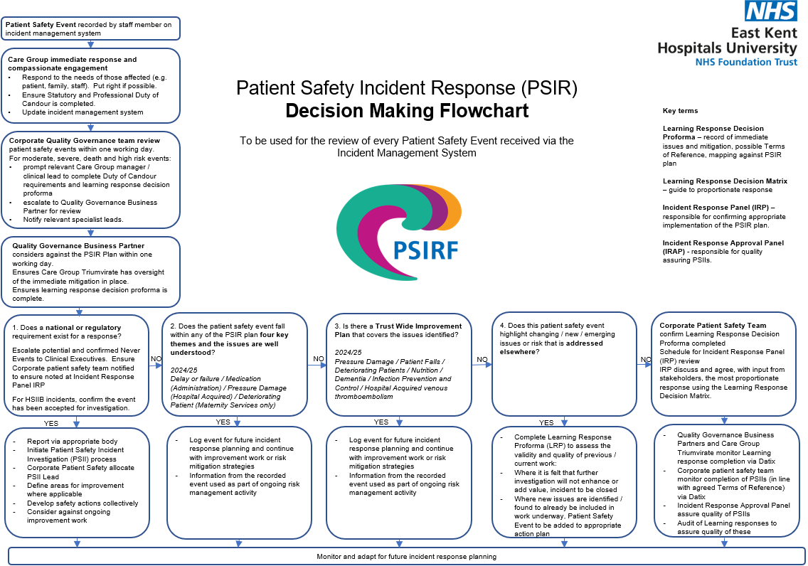

Appendix 3: Quality Governance Structure Chart

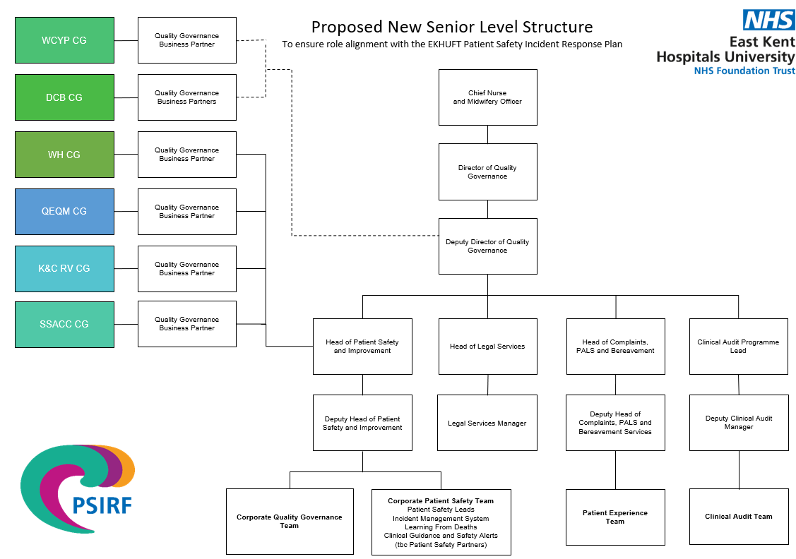

Appendix 4: Equality Analysis

An Equality Analysis not just about addressing discrimination or adverse impact; the policy should also positively promote equal opportunities, improved access, participation in public life and good relations.

**Person completing the Analysis**

Job title: Deputy Director of Quality Governance

Care Group/Department: Quality Governance Directorate

Date completed: 05 April 2024

**Who will be impacted by this policy**

[x] Staff (Trust)

[x] Staff (Other)

[x] Clients

[x] Carers

[x] Patients

[x] Relatives

**Assess the impact of the policy on people with different protected characteristics**

When assessing impact, make it clear who will be impacted within the protected characteristic category. For example, it may have a positive impact on women but a neutral impact on men.

| **Protected characteristic** | **Characteristic Group** | **Impact of decision**  Positive/Neutral/Negative |
| --- | --- | --- |
| **Age** | Older people are more likely to be affected by a patient safety incident, due to the profile of patients in the Trust’s care. Having a robust policy and process, with inclusive involvement will benefit older patients. Consideration needs to be given the parents of children and young people affected by a Patient Safety incident. | Positive |
| **Disability** | Disabled people (as defined by the Equality Act 2010). are more likely to be affected by a patient safety incident, due to the profile of patients in the Trust’s care. Having a robust policy and process, with inclusive involvement will benefit disabled people, including people with learning disabilities and autism, people with dementia, and people with long-term health conditions | Positive |
| **Gender reassignment** | Research shows that transgender people risk significant harm given the number of transpeople who opt to free birth. Providing a safe and inclusive care environment for transgender people will improve patient safety. | Positive |
| **Marriage and civil partnership** | All | Neutral |
| **Pregnancy and maternity** | Women who are Black, Asian or other White are more likely to experience harm and more likely to lose a baby whilst pregnant or after birth. Improving the management and learning from patient safety incidents related to Maternity will be part of improving outcomes for all women. | Positive |
| **Race** | Women who are Black, Asian or other White are more likely to experience harm and more likely to lose a baby whilst pregnant or after birth. Improving the management and learning from patient safety incidents related to Maternity will be part of improving outcomes for all women | Positive |
| **Religion or belief** | All | Neutral |
| **Sex** | All | Neutral |
| **Sexual orientation** | LGBTQIA+ people experience discrimination when using healthcare services and therefore may be less likely to access services or to raise a concern when there is an incident. Having inclusive practice and inclusive | Positive |

If there is insufficient evidence to decide about the impact of the policy it may be necessary to consult with members of protected characteristic groups to establish how best to meet their needs or to overcome barriers.

**Has there been specific consultation on this policy?**

N/A

**Did the consultation analysis reveal any difference in views across the protected characteristics?**

No

**Mitigating negative impact:**

(Where any negative impact has been identified, outline the measures taken to mitigate against it.)

None

**Conclusion:**

(Advise on the overall equality implications that should be considered by the policy approving committee.)

The are many positive implications to the implementation of this policy. There is a specific focus within PSIRF for the Trust to address health inequalities as well as a much greater emphasis on the engagement of all parties that would be affected by an incident occurring.

Appendix 5: Policy Implementation Plan

**Policy Title:** Patient Safety Incident Response Policy

**Implementation Lead:** Deputy Director of Quality Governance in partnership with the Head of Patient Safety and Improvement

**Staff Groups affected by policy:** All staff

**Subsidiary Companies affected by policy:**

Spencer Private Hospitals

**Detail changes to current processes or practice:**

* Our response to incidents, method of investigations and level of engagement of those affected is changing.
* Greater involvement of staff and patients and their families in the incident investigation.
* Higher standards of the role of the investigator and investigation to be applied.
* Oversight from the ICB will adapt to becoming a collaborative approach to provide assurance.

**Specify any training requirements:**

* Refer to Table 2 in section 10.2.5

**How will policy changes be communicated to staff groups/ subsidiary companies?**

* Via the Patient Safety Communication (Comm) plans
* Information sessions to staff
* The Deputy Director of Quality Governance will disseminate the policy to the Subsidiary Company.